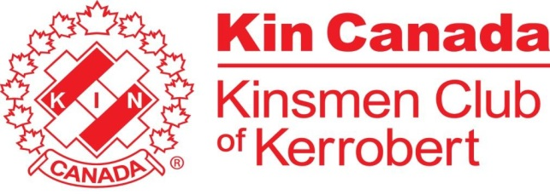
Kinsmen Club of Kerrobert Scholarship
Eligibility:
- Any student graduating from the Kerrobert Composite High School that is taking any post-secondary education within 5 years of their graduation.
- Student must be a well-respected role model within our community.
- Student must have portrayed strong values in volunteerism.
Applications must be submitted no later than June 1st, 2020.
The application letter to the Kinsmen Club of Kerrobert must highlight:
- Your plans to further your education
- Your commitment to bettering the world we live in
- What volunteering means to you
- Examples of the volunteer work you’ve been involved with in our community
The selection will be made by the Kinsmen Club of Kerrobert & pending the occurrence of a public graduation ceremony, the recipient will be announced at that ceremony or through a live video announcement.
A $500 cheque will be given to the recipient once they provide a receipt of their tuition payment or show proof of post-secondary enrolment.
For further information or questions, call Chad Tetzlaff at 306-834-8025.
Applications can be submitted to Chad Tetzlaff or directly to the Kinsmen Club. E-mail a copy to chad_tetzlaff@hotmail.com or by mail to the address below:
Kinsmen Club of Kerrobert
Box 441
Kerrobert SK, S0L 1R0

