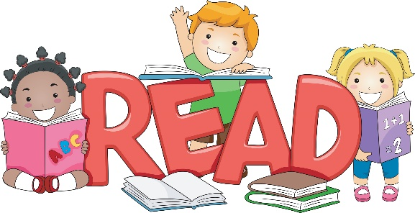

Grade 3 Guided Reading Resources (2017-18)

Package A  Early Readers | Scholastic Canada Ltd.
Package A  Early Readers | Resource | Qty. | Price | ISBN
Package A  Early Readers | AlphaKids Set 1, Level 12 Library Pack | 3 sets | $37.50/each | 9780779107483
Package A  Early Readers | AlphaKids Set 1, Level 13 Library Pack | 3 sets | $37.50/each | 9780779107490
Package A  Early Readers | AlphaKids Set 1, Level 14 Library Pack | 3 sets | $37.50/each | 9780779107506
Package A  Early Readers | AlphaKids Set 1, Level 15 Library Pack | 3 sets | $37.50/each | 9780779107513
Package A  Early Readers | Package A includes 3 copies of each title, Levels G-I. There are 20 titles included, 60 books in total. This is a great package for students who are at beginning Grade 2 Level with their reading.

Package B  Developing Readers | Nelson Education Ltd. (Nelson School Central)
Package B  Developing Readers | Resource | Qty. | Price | ISBN
Package B  Developing Readers | PM Library Orange (I) Traditional Tales and Plays Single Copy Set | 3 sets | $57.50/each | 9780176213374
Package B  Developing Readers | PM Library Turquoise (J-K) Wild Animal Facts Single Copy Set | 3 sets | $57.50/each | 9780176213428
Package B  Developing Readers | PM Plus Purple Nonfiction (L) Nonfiction Single Copy Set | 3 sets | $57.50/each | 9780176194017
Package B  Developing Readers | Package B includes 3 copies of each title, Levels I-L. Tales and Plays, Wild Animal Facts and general Nonfiction are included. There are 18 titles, 54 books in total. This package is for students who are at mid to end of Grade Two reading level.

Package C  Fluent Readers | Nelson Education Ltd. (Nelson School Central)
Package C  Fluent Readers | Resource | Qty. | Price | ISBN
Package C  Fluent Readers | PM Early Chapters Gold (L-N) Gold Single Copy Set | 3 sets | $57.50/each | 9780176113292
Package C  Fluent Readers | PM Plus Gold Nonfiction (M-N) Gold Nonfiction Single Copy Set | 3 sets | $57.50/each | 9780176197209
Package C  Fluent Readers | PM Library Silver (N-O) Silver Polar Animal Facts Single Copy Set | 3 sets | $57.50/each | 9780176213534
Package C  Fluent Readers | Package C includes 3 copies of each title, Levels L-O. Polar Animals, general Nonfiction and Early Chapter Books are included. There are 18 titles, 54 books in total. This package is good for students who are reading at grade level.

Package D  Fluent Readers First Nations Content | Pearson School Canada
Package D  Fluent Readers First Nations Content | Resource | Qty. | Price | ISBN
Package D  Fluent Readers First Nations Content | Turtle Island Voices Grade 3 Class Set | 1 set | $468.50 | 9780132670425
Package D  Fluent Readers First Nations Content | Package D Pearson School Canada: Turtle Island Voices Levelled Books  - There are 10 titles at a range of appropriate levels for the grade.  - Includes the Teacher’s Guide plus six copies of each of the ten titles for the grade.  - The books reflect a wide variety of culture areas, from the West Coast to the East.  - There are traditional stories, modern stories, and informational texts.

