After reading each sentence, think about whether you get it (“click”) or it’s confusing (“clunk”). As you read it should feel like “Click, click, click.” When you hit a “clunk” go back and reread to be sure you understand.

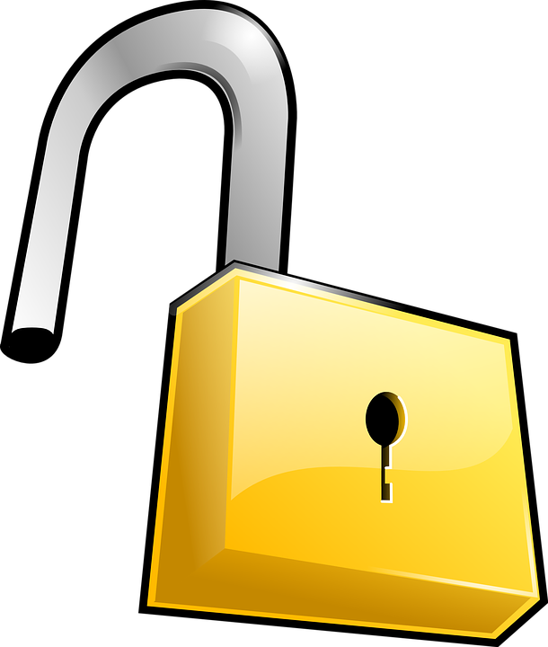

Is it a Click?
Keep reading

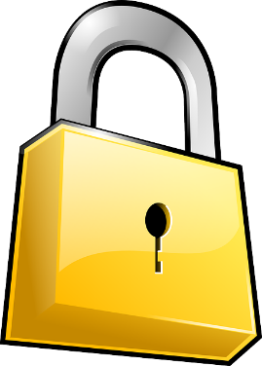
Or is it a Clunk?
Reread

Do You Get it?

Prompts:
Did you understand that?
Check yourself before moving on
Did it make sense? Did it “click?”
You didn’t understand. Go back and reread
Make sure you’re understanding!
Think to yourself as you’re reading.

Source: Jennifer Serravallo, Reading Strategies Book Your Everything Guide to Developing Skilled Readers, Heinemann, 2015.

