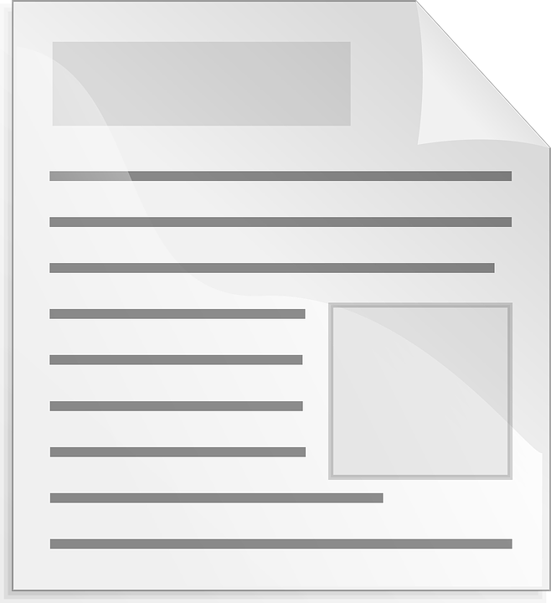
The photo is …

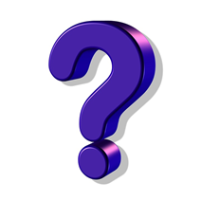

Topic sentence….

What might the main idea be?

Survey the text by glancing at the big things that jump out at you visual—heading(s), title(s) and visual(s)? Ask yourself “What does it seem like this text is mostly about. Then go back and read the text with that main idea in mind. Check the facts you learn to see if they really do fit with the main ideas statement you’ve already made. When you finish reading, revise the main idea statement based on the new information you have.

Prompts
Look across the page. Tell me what you see.
If you put all the visuals together, what do you think it’s mostly about?
What do most of the features have in common (topic or idea?)
Check the facts to make sure that’s the main idea
Do you have any changes to make to your main idea statement, after reading the facts?
Hmm. It seems like that doesn’t quite fit. Revise your thinking.
You put the visuals together to figture out what it’s mostly about!

Source: Jennifer Serravallo, Reading Strategies Book Your Everything Guide to Developing Skilled Readers, Heinemann, 2015.

