RECEPTIVE: Which jar is empty?

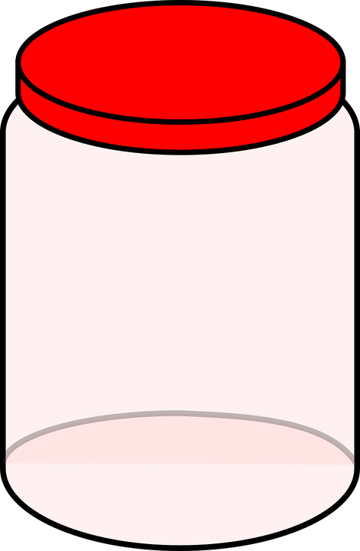
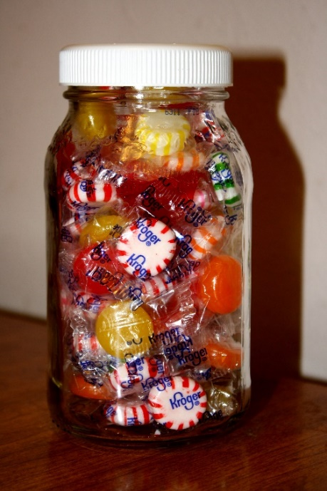

EXPRESSIVE: You showed me empty. This jar is ………..

RECEPTIVE: Which girls look the same?

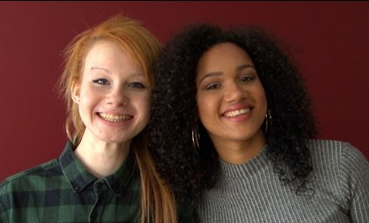


EXPRESSIVE: You showed me the same. These girls look ………..
RECEPTIVE: Which animal is heavy?

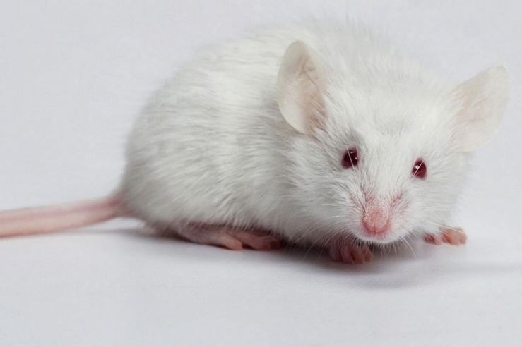
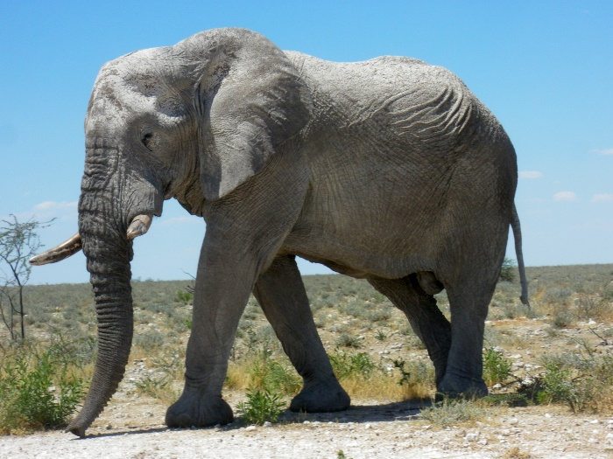

EXPRESSIVE: You showed me heavy. This animal is ………..

RECEPTIVE: Which clown is short?

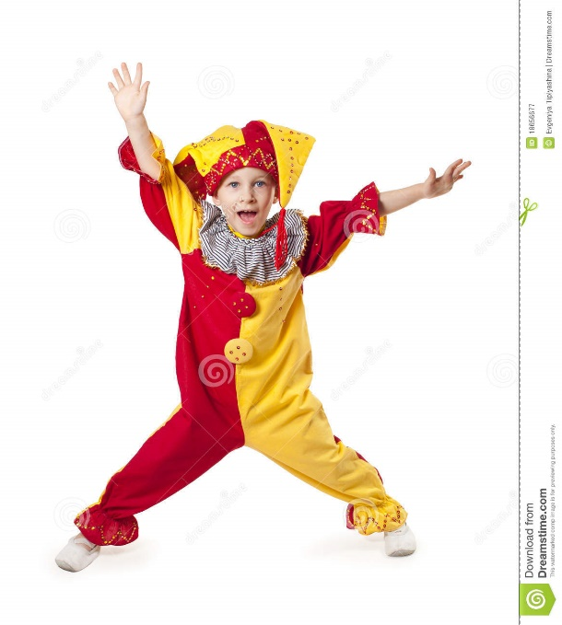
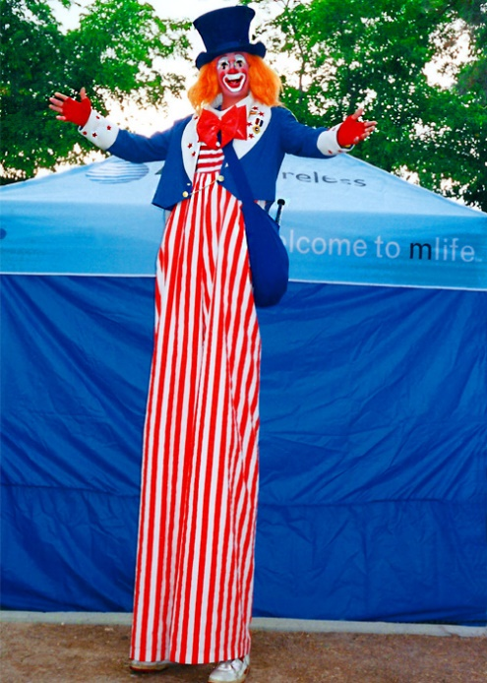

EXPRESSIVE: You showed me short. This clown is ………..

RECEPTIVE: Which wall is rough?

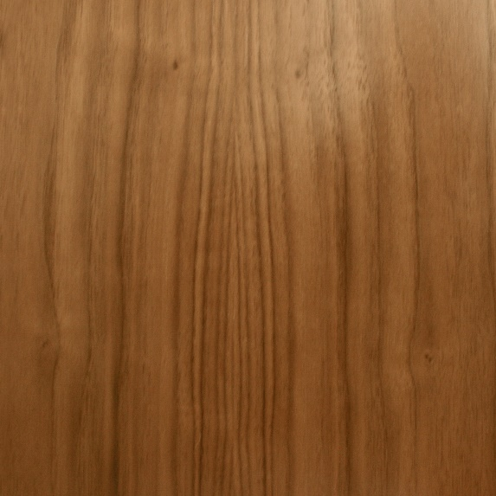
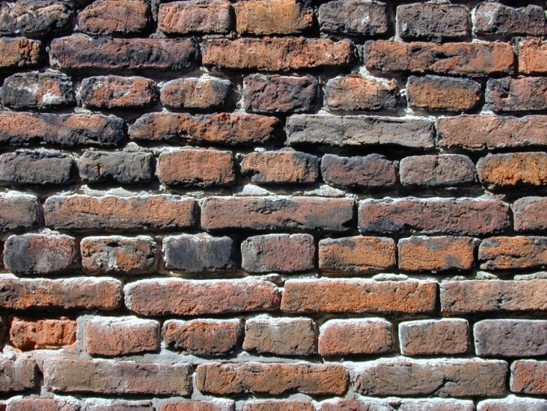

EXPRESSIVE: You showed me rough. This wall is ………..

RECEPTIVE: Which picture shows day?




EXPRESSIVE: You showed me day. This picture shows ………..
RECEPTIVE: Which picture shows before the party?

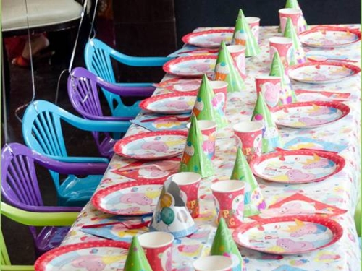



EXPRESSIVE: You showed me before the party. This picture shows ………..
RECEPTIVE: Which student is first in line?

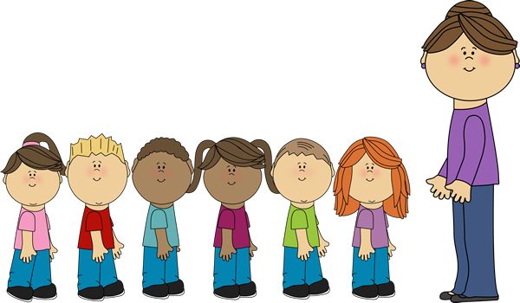

EXPRESSIVE: You showed me first. This student is ………..

RECEPTIVE: Which child has all the balloons?
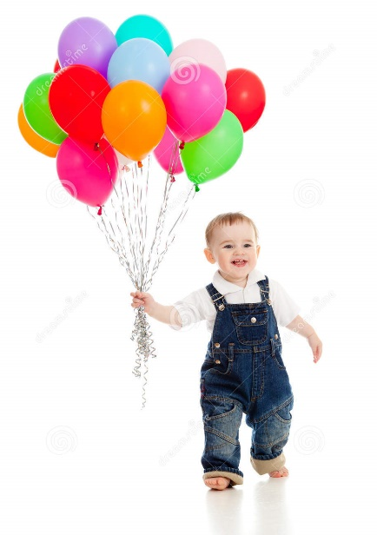

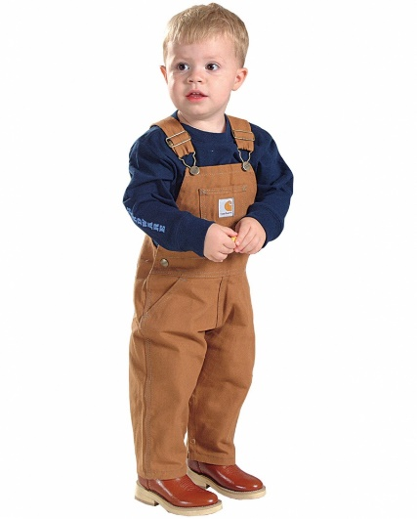

EXPRESSIVE: You showed me the boy with all the balloons. This boy has ………..

RECEPTVE: Which man has more fish?

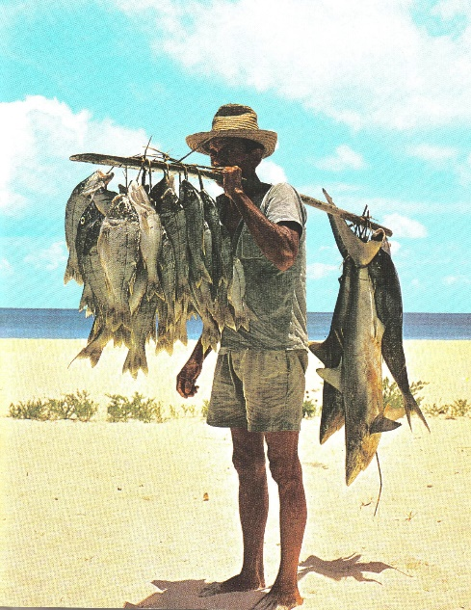



EXPRESSIVE: You showed me more. This man has ………..

RECEPTIVE: Which picture shows half a cake?

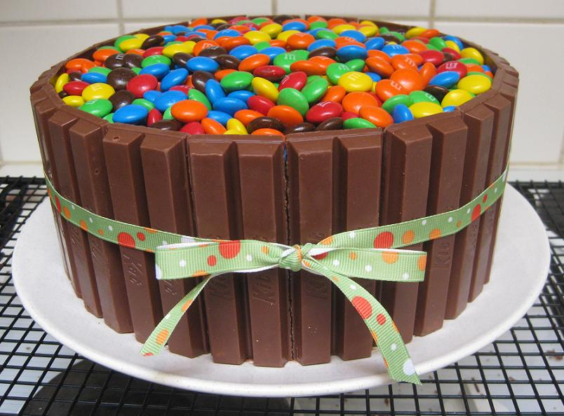
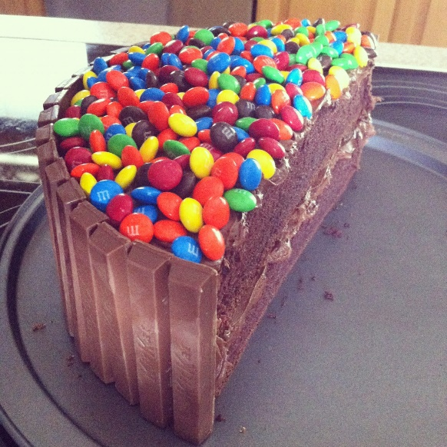

EXPRESSIVE: You showed me half a cake, this cake is …….
RECEPTIVE: Which animal is going under the fence?

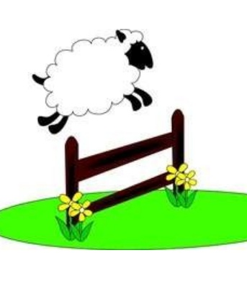
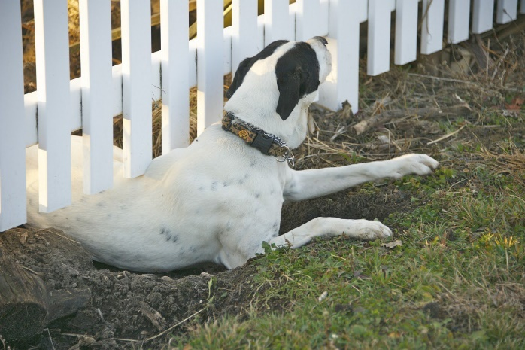

EXPRESSIVE: You showed me going under, this animal is going ……..

RECEPTIVE: Which animal is in front of the tree?

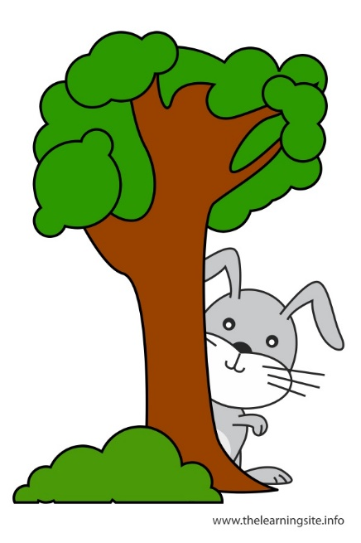
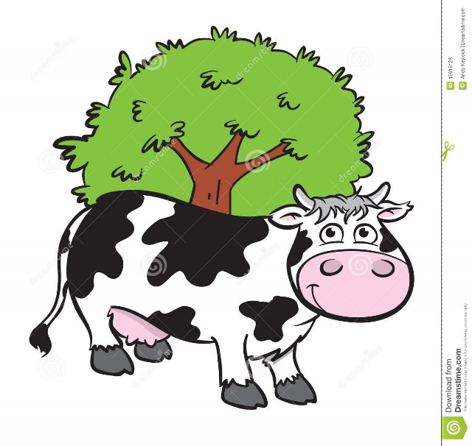

EXPRESSIVE: You showed me in front. This animal is …

RECEPTIVE: Which toy is on top of this pile?


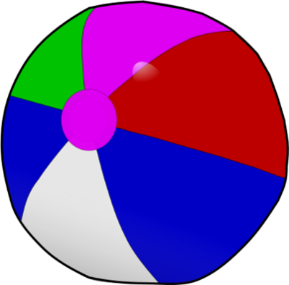



EXPRESSIVE: You showed me the top, the police car is on the ……….
The beach ball is in the……..
RECEPTIVE: Which train is going through?

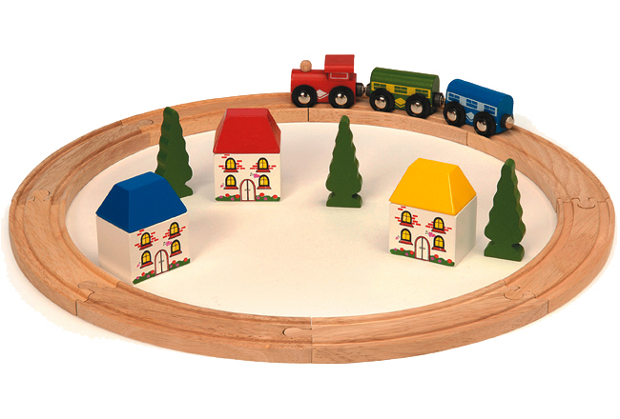

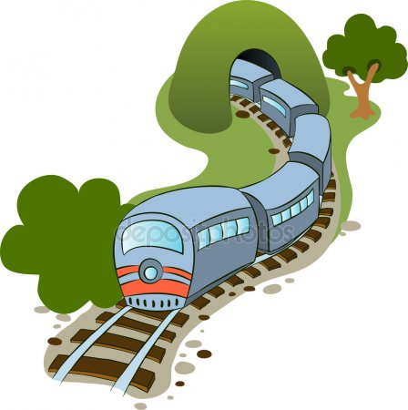

EXPRESSIVE: You showed me going through, this train is going ……….
RECEPTIVE: Which apple is beside?
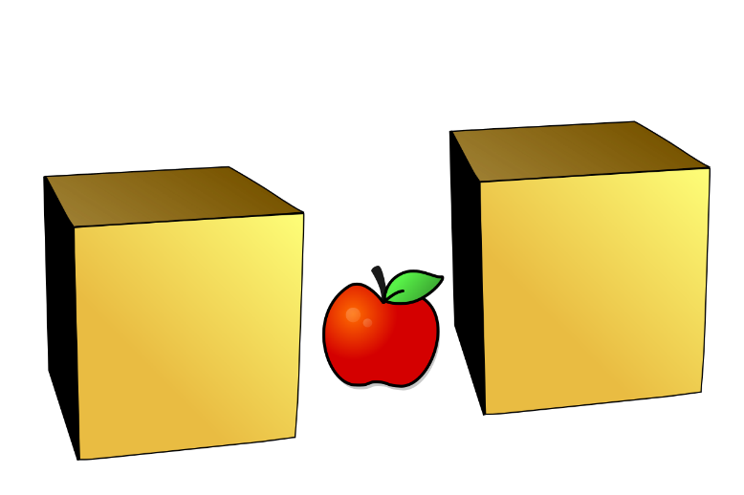

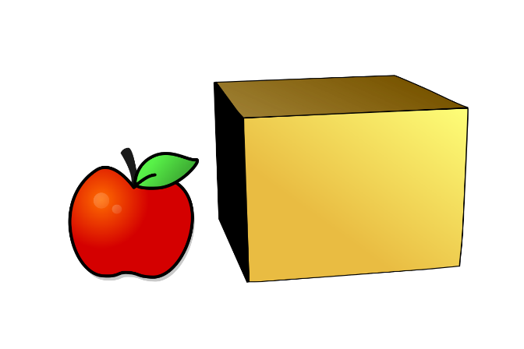

EXPRESSIVE: You showed me beside, this apple is ……

RECEPTIVE: Put your hands on the picture. Which is your left hand?

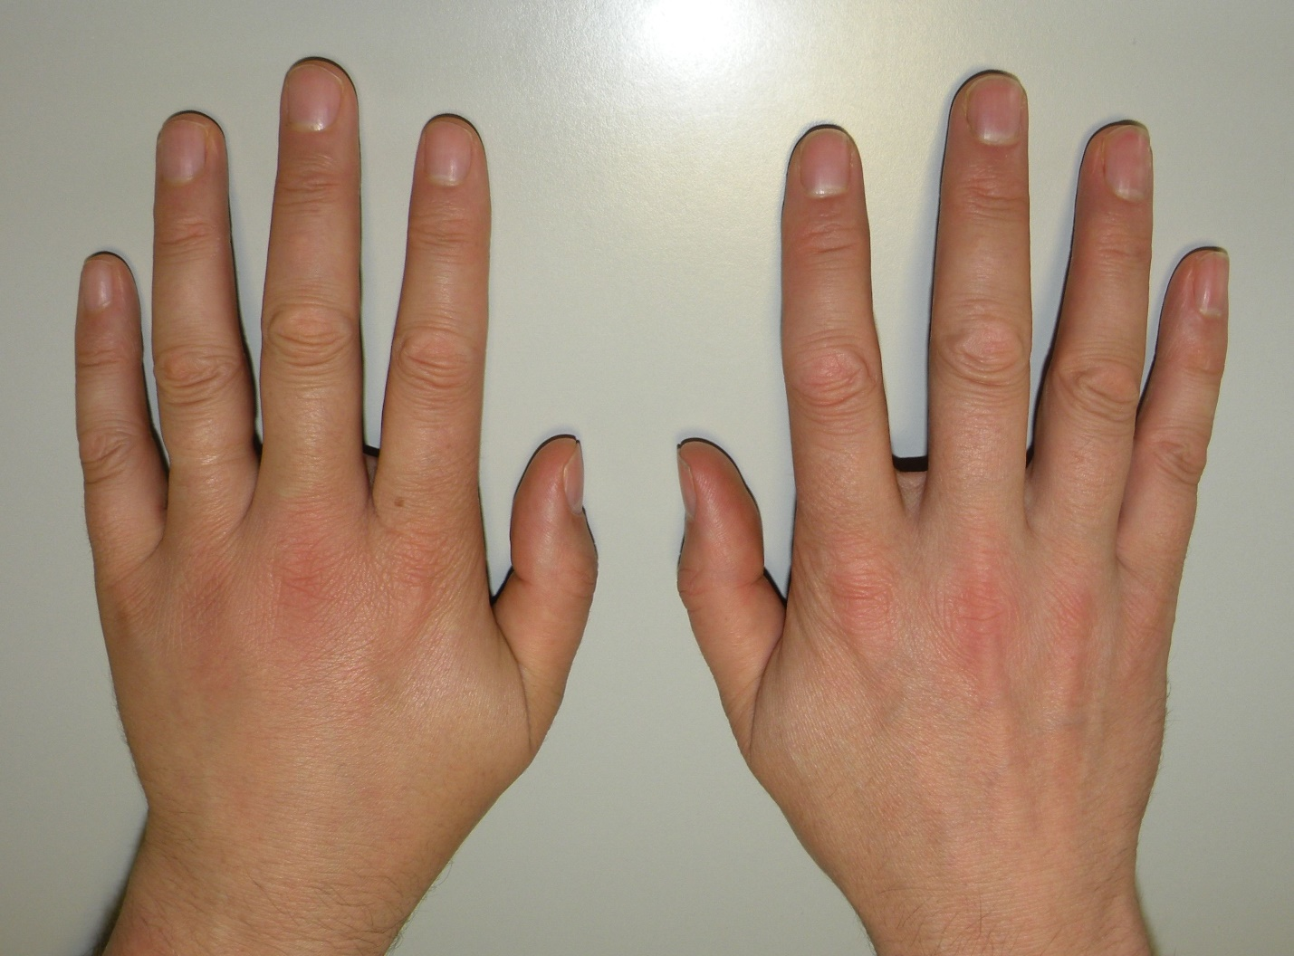

EXPRESSIVE: You showed me your left hand, this is your ……

