Dog
4

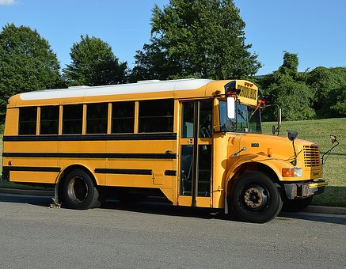
B

The boy got on the bus. He went to school on
the bus. The boy liked to play with his
friends.

