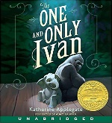
The One and Only Ivan by Katherine Applegate

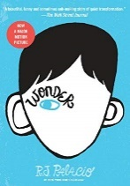
Wonder by R.J. Palacio

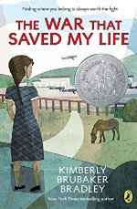
The War that Saved My Life by Kimberly Brubaker Bradley

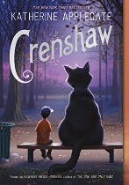
Crenshaw By Katherine Applegate

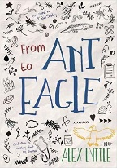
From Ant to Eagle by Alex Lyttle

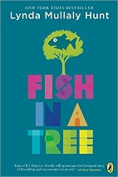
Fish in a Tree by Lynda Mullaly Hunt

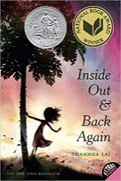

Inside Out & Back Again by Thanhha Lai
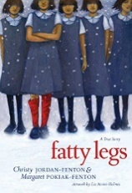
Fatty Legs by Christy Jordan-Fenton

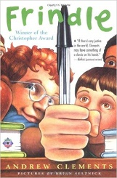
Frindle by Andrew Klements

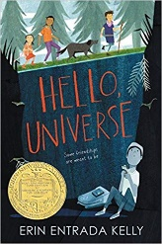
Hello Universe by Erin Entrada Kelly

