 | Book Clubs  Getting Started  Inside: Tips for starting books clubs in elementary classrooms. Book selection, Text sets, Groups size, Scheduling, Structure, Preparation, Tools for discussion, Extensions, and the Role of the Teacher in Literature discussions.  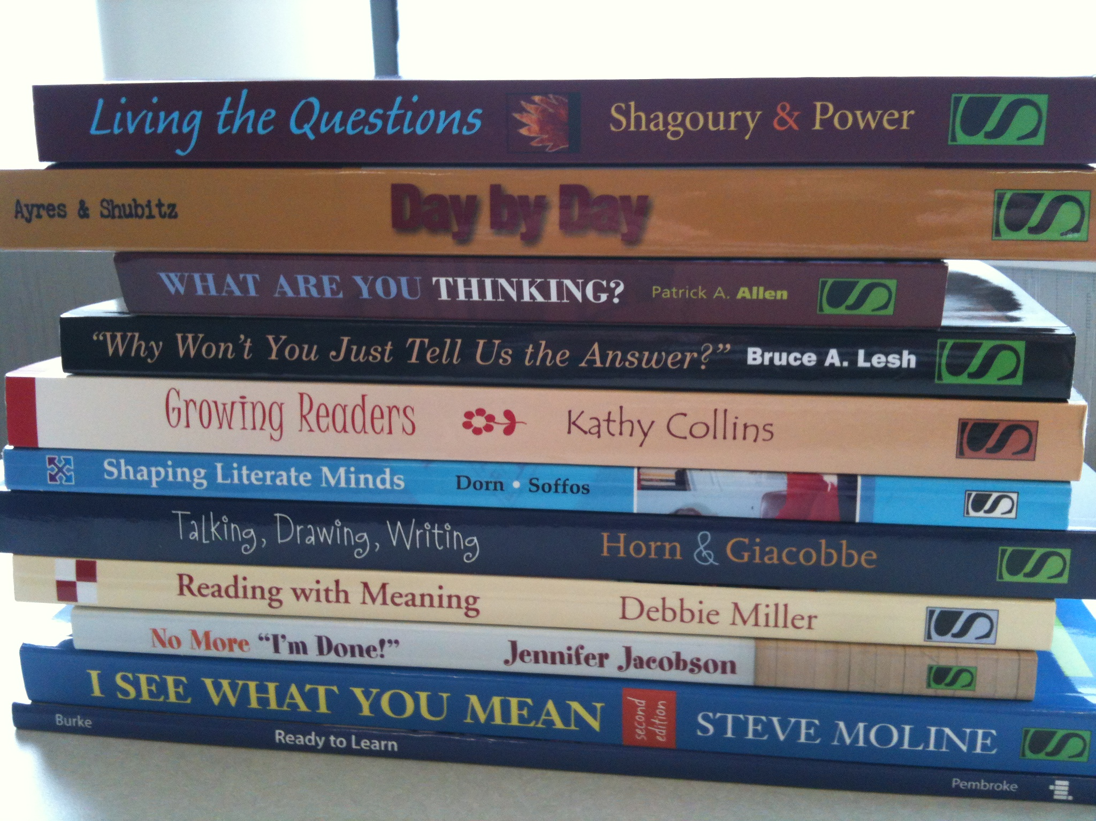  READ    WRITE  Making the most of book clubs…  Read, Write, Think, Talk, Study, Create, Share
    - Start with Beliefs
  “Every year is its own story, coauthored with students…
  Our best work happens when we align our instructional decisions to our student’s strengths...
  When our children become our curriculum, their actions our data, their potential our standards. Students are at the center of our work. “
  Kelly Gallagher & Penny Kittle, 180 Days, 2018
  
  Kate Carlisle, Living Sky School Division No. 202, September, 2018
 | Book selection:  - Select great books that are appropriate for the age and level of sophistication of the students in your class.  - Choose high quality texts that are well written and have multiple layers of meaning.  - Include books that you and your students love.  - Find texts that have significance and good potential for discussion (include issues questions, or topics that students will want to talk about).  - Select text in the range that most students can read independently…but realize that you can offer more support to those who need it. (e.g. Audio books)  - When possible connect to social studies and science curricula so students can make connections.  - Put together sets of texts with similar themes but different reading levels so that you can accommodate a diversity of students  Text sets:  Possible categories include:  - Author study  - Genre study (e.g. informational, biographies, historical fiction, traditional literature, realistic fiction)  - Books on the same theme (books that show the human condition over time and cultures in relation to such issues as family closeness, friendship, courage, war, prejudice, death, etc.)  - Paired fiction and non-fiction selections (for example works of historical fiction and factual books about the same time period)  - Biographies (revolutionary figures, public figures, scientists, activists, courageous people)  - Turning points (critical events, hard choices, or decisions that changed people’s lives)  - Different versions of the same story (historical fiction, informational account, folk tale, myth)  - Content (a range of factual books on the same topic—period of history, scientific process, contemporary issue)  - Characters (books that have similar characters—for example characters who have fought for the same causes, overcome adversity)  - Text structure (books that have similar organizational patterns or structures, such as flashbacks or stories within stories)  - Series (books that relate the adventures over time of the same characters)  - Books with similar plots (for example, quests or fantastic journeys)    Group size:  Four to six students works well. Groups should be heterogeneous. Often, the more diversity in the group the better the discussion will be. Smaller groups provide more opportunity for all students to actively participate and get to know one another’s point of view. Composition of groups can also vary by interest. Students benefit greatly from talking about their ideas.    Scheduling:  Consider class size, group size and the nature of the text. Book clubs can meet daily, every other day, twice a week, weekly, or several times over a two-week period. Meeting several times over a two-week period works well for longer texts that are broken into segments. Make a predictable schedule so students know when to expect to participate. For example:  Book Club Structure:    The teacher can introduce the books for book clubs through short book talks and then let students make a selection. Students could indicate their first, second and third choices on a slip of paper.  Most often, students read and discuss the same title. In the jigsaw model, students could each read a different book and when they meet, tell one another about their books, respond to questions, and explore how the titles are related (in a series for example).  The teacher prepares the students for book clubs by modelling the thinking process in short interactive read-aloud lessons to teach students many of the skills they will need to engage in successful literature discussion groups. Refer to the excerpts from Teaching for Comprehension and Fluency, later in this document: Minilessons to support Literature Discussion, Getting Started the First 35 Days and the Teachers Role in Literature Discussion    Prepare:  Students read and prepare for book club discussion while reading independently at school and / or at home. While reading they select information and ideas to share. Students prepare by reflecting thoughtfully, raising questions and identifying specific examples from the text that they want to discuss with the group.    Thinking  Students’ thinking about the text that they are reading is a critical aspect of preparing for book club discussions.  Tools for Discussion    Students can bookmark the text using sticky notes or jot down page numbers so that they can quickly take the group to the pages to which they wish to refer. They could use a “think mark,” a type of bookmark on which they note page numbers, or fold an 8 ½ by 11 piece of paper in half and write notes and page numbers as they read a section. When they read a new section they turn it over and the inside out. By the time they finish there are notes on all four sides.  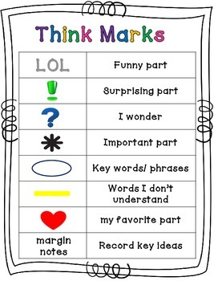  They could also use a reader’s notebook (Thought log) that they bring to the group. Assignments should not be so prescriptive that they limit students’ responses (having one write about characters and another about setting for example). The “Track Your Thinking” template on the following page (from 180 Days), can be included in student’s thought log notebooks to stimulate thinking to prepare for discussion.  TRACK YOUR THINKING  I used to think__________, but now I think _______________.  I still think _____________, but I’d like to add _____________.  Others think____________, but I think ___________________.  Things to track over time  A character:  - How does the character change?  - What does the character learn?  What big ideas are being developed?  - What conflict or problem arises?  - What does this tell the reader?  What techniques/moves does the writer make?  - What are the key passages? Why?  - Notice beautiful sentences/passages. Comment on them.  Track your confusion  - What is confusing at the beginning of the book? Does the confusion remain or does it clear up?  - What passages/sentences/words do you find confusing?  Thought starters:  - I noticed …  - I wonder …  - I was reminded of …  - I think …  - I’m surprised that …  - I’d like to know …  - I realized …  - If I were …  - The central issue(s) is (are) …  - One consequence of …could be …  - If… , then …  - I’m not sure …  - Although it seems …  “That” statements:  - This passage makes me think that …  - This makes me feel that …  - The author is suggesting that …  Source: Figure 3.5 Track your thinking chart, p 58, 180 Days  Discuss  Students bring their “thought logs” to the group and discuss the text for a designated period of time (beginning with about 10 minutes and increasing to twenty to thirty minutes). They might begin by bringing one thought and one comment to the first meeting. Prompts and questions can be provided to move the discussion ahead, if students run out of things to talk about.  Evaluate  At the end of the meeting students take a few minutes to evaluate how things went and set goals for how they can improve their next discussion. Criteria for this can be co-constructed with students before the book club begins, and modified as needed, and might include some of the following areas: Coming prepared, sharing thinking, listening to the person speaking, staying on topic, respectful communication, being inclusive, using examples from the book, asking questions, allowing everyone to express their thoughts. An example is provided later in this document. Occasionally students might do a quick write, in their reader’s notebook to write about how their thinking was extended or changed by talking with the group.  Extend  Students can write briefly or sketch as part of their preparation for book clubs or after reading a book. Extensions can deepen understanding by responding to the whole book and to the conversation that took place around it.  To extend a text a student might:  - Select a quote that is significant and tell why.  - Make a T chart in their reader’s notebook—on the left side “what I think” and on the right side “Evidence from the text/personal experience”.  - Write a book review or a book recommendation.  - Write a letter or prepare questions for the author.  - Assume the role of a character and write a diary entry or letter.  - Draw or sketch something from the text that shows a significant event or development.  - Learn more about the author, the topic, or the setting (using reference material or the internet).  Key focus Questions for Thought Logs:  Consider:  Who is in the book and how are they connected?  What is worth talking about?  What are the “big ideas”?  What is the shape of the story? (see next page)  Prepare one comment and one question…    Craft:  How is the book written?  What does the text say? What does it mean?  How does the writer convey deeper meaning?  Consider: Point of view, mood, imagery, character development, use of dialogue  The Shape of a Story:  Questions to Navigate a Story  Figure 3.6, p. 62, 180 Days  The Teacher’s Role in Literature Discussion:  RESPONSIBILITIES:  The teacher begins as the leader and gradually releases responsibility to the students, becoming a facilitator, a participant, an observer, and an evaluator.  Leader  - Opens the discussion. Establishes expectations and occasionally remind students of them.  - Teaches routines. Guides the discussion through comments and questions. Helps students summarize and conclude the discussion. Keeps the discussion grounded in the text.  - Provides strong support to help students get started.  - Provides teaching to help students understand the expectations of book club. Demonstrates text talk. Helps students become clearer about what they are learning.  - Helps students focus their talk and use more complex language.    Facilitator  - Sets the scene for and invites discussion.  - Withdraws from the group but stays nearby.  - Occasionally steers the conversation by asking critical questions.  - Intervenes to help the group remain focused and to ask individuals to clarify points.  - Intervenes to help students get a turn if this is not happening.  - Provides the support necessary to help students learn to discuss texts more independently.  - Provides enough support that the discussion is productive and keeps the discussion from rambling or going off on tangents.  - Helps students as they learn responsibility for taking charge of the book club discussions themselves.  Participant  - Acts as a member of the group, contributing occasionally, and sometimes steering the discussion so all students have a chance to speak.  - Models all the interactive moves—verbal and nonverbal—that students will be expected to use.  - Models participation and “text talk”—the expression of many ways of thinking about a text.  - Helps students gain the benefit of a sophisticated participant's contributions and sometimes “lifts” the discussion with personal contributions.  - Provides a light level of support as students learn to take responsibility for managing the group.  - Provides a presence that reminds students of expectations and a good model from which they can learn.    Observer  - Withdraws from the group but stays nearby.  - Listens but does not usually participate.  - Occasionally leans in and offers a comment or question.  - Takes notes to document information for future teaching plans.  - Communicates to students that their discussion is important.  - Provides the opportunity for students to work independently.  Evaluator  - Evaluates the quality of the discussion and occasionally provides feedback.to the group.  - Evaluates student comments as evidence of learning.  - Compares evidence of learning to curriculum goals.  - Gathers information for future teaching in mini-lessons  - Prompts students’ self-evaluation.  Evaluating Literature Discussion:  Sample Checklist  Preparation:  - Read the assigned pages.  - Made notes and/or identified pages or parts in the text  - Completed a writing or drawing assignment if assigned.  Discussion-Process:  - Came to the group prepared.  - Attended to and looked at the speaker.  - Spoke clearly, loudly enough for others in the group to hear.  - Spoke to other members (not just the teacher).  - Contributed an appropriate amount, taking turns with others.  - Asked others for clarification when needed.  - Asked follow-up questions.  - Built on the comments of others.  - Encouraged others to share their thinking.    Discussion-Content:  - Contributed accurate information from the text.  - Showed familiarity with the text by providing specific examples to support thinking.  - Used prior knowledge to extend understanding of the text.  - Identified and discussed literary features of the text.  - Recognized and discussed examples of the writer's style or craft.  Discussion-Strategies:  - Provided evidence of literal understanding of the text through summary and important information.  - Went beyond the text in thinking to make inferences.  - Went beyond the text to make personal, world, or text connections.  - Went beyond the text to make predictions.  - Went beyond the text to incorporate or synthesize new information and ideas into their thinking.  - Noticed aspects of the text such as language, structure, or writer's craft.  - Provided evidence of critical thinking about the text.    Assessment:  - Noticed aspects of the discussion that were productive.  - Identified areas of needed improvement, providing specific examples from the discussion as evidence.  - Assessed self as individual participant.  :  Minilessons to Support Literature Discussion:  Procedural Lesson Goals  - How to select a book for literature discussion  - How to prepare for a discussion  - How to take notes, make sketches, write questions, or reflect in a reader’s notebook before discussion  - How to get the discussion started  - How to participate in a discussion.  - How to keep the discussion moving.  - How to encourage one another’s thinking  - How to respect one another's ideas.  - How to make the discussion interesting (build on one another’s ideas).    - How to disagree politely.  - How to listen actively (use positive body language, make eye contact).  - How to take turns speaking in a discussion  - How to ask questions.  - How to vary language  - How to summarize and evaluate a discussion (what went well, goals for next time).  - How to seek clarification (“I am confused,” or “I don’t understand what you mean.”)  - How to write in a reader’s notebook after a discussion.  - How to use language that facilitates discussion.  - How to use language that helps others understand better or clarifies, (“What do you mean? Talk more about that. Why do you think that? What did the author say that made you think that?”)  C  CContent: Strategies and Skills Lesson Goals:  - Noticing important information in the text or art.  - Making predictions as you read.  - Connecting your personal experiences and knowledge to the text.  - Using evidence from the text or personal experience to support your thinking.  - Noticing interesting or new vocabulary.  - Recognizing clues provided by the author.  - Predicting the story ending or events following the story.  - Judging the believability of the story.  - Summarizing the story.  - Identifying unanswered questions.  - Connecting other texts, authors, and illustrators to the text.  - Analyzing the story title.  - Synthesizing the greater meaning of a text.  Content: Literary Analysis Lesson Goals  - Recognizing the narrator.  - Identifying the author's perspective.  - Identifying the challenges characters encounter.  - Identifying the choices characters have.  - Analyzing how a character affects others.  - Recognizing the most important event in the story.  - Recognizing the shape of the story-circular, linear, triangular.  - Recognizing the order of events as they are told (sequence, flashback).  - Noticing how the author makes the story realistic.  - Finding memorable words or phrases.  - Noticing strong verbs.  - Noticing figurative language: simile, metaphor, personification.  - Identifying and analyzing the lead or how the author engaged the readers.  - Recognizing the high point or climax of the story.  - Recognizing the problem in the story and attempting to solve the problem.  - Recognizing the genre-  - Responding to the text in writing and drawing.  Getting Started: The First 35 days:  The following lessons represent a potential scope and sequence for introducing book clubs. Combine these lessons as needed to be responsive to your students:    Making Good Book Choices: Readers can listen to book talks and look through books to help them make good book choices.  Preparing for Book Club: Readers prepare for book club by reading and thinking about the assigned pages so they can contribute to and learn from the discussion.  Getting Started Quickly: Readers quickly and quietly take their chairs and books, get in a circle, and start the discussion so they can make the best use of time.  Respecting Group Members: Readers look at the speaker and show their attention so the speaker feels they value each other's thinking.  Respecting One Another's Thinking: Readers show respect for one another's thinking so others will feel good about sharing.  Participating Actively: Readers share their thinking by making comments and posing questions so others can learn from, add to, or challenge their ideas.  Listening Well: Readers listen to the thinking of others so they can understand and learn from their ideas.  Taking Turns: Readers wait for a person to finish speaking before they start speaking so that everyone can hear and understand.  Building on Ideas: Readers build on one another's ideas so they can make the discussion more interesting. Readers add to the comments of others so they can examine one another's thinking more deeply.  Disagreeing Politely: Readers disagree in polite ways so they can help one another understand more.    Encouraging Group Members: Readers encourage one another to share their thinking so they can feel good and learn a lot from the discussion  Marking Sentences or Passages: Readers jot down or mark sentences or passages that they want to discuss in the group so they can find them quickly and easily.  Noticing Memorable Language: Readers notice the language (words, phrases, or sentences) writers use so they can think about their meaning.  Noticing Important Information: Readers notice important information as they read so they can understand the author's message:  Noticing Important Information: Readers notice the information in the art or illustrations so they can fully understand the meaning of the text.  Using Sticky Notes to Mark Places: Readers use sticky notes to mark places in the book that they find interesting or confusing, so they c go to the places quickly during group discussion.  Making Notes for Discussion: Readers make notes and list page numbers so they can go to the places in the book quickly during group discussion.  Using a Thinkmark to Make Notes: Readers use a thinkmark to note places they want to discuss so they can find them quickly in group discussion. (A thinkmark is simply a bookmark with lines on which to make notes or list page numbers.)  Writing Personal Reflections and Questions: Readers write their own thoughts or questions before group discussion so they can do their own thinking before hearing the thinking of others.  Reflecting After Discussion: Readers write about or sketch their thinking after group discussion so they can examine and extend their understanding.  Supporting Your Thinking with Evidence: Readers support their thinking with personal experience or evidence from the text so others can understand the reasons for their statements.  Searching for Information: Readers ask questions so they can better understand the thinking of other speakers. For example: "What do you mean by that?" "Say more about that." "Why do you think that?" "What did the author say that made you think that?"    Sharing Your Thinking: Readers tell about their thinking so others can learn from their ideas.  Summarizing the Learning: Readers comment on what they learned at the end of the discussion so others can understand what they thought was important.  Evaluating the Discussion: Readers discuss what went well and what needs to work better and set goals so discussions can improve.  Making Choices for Book Club: Readers list their first, second, and third choice books so the teacher can make groups and try to assign each person one of their best choices.  Having a Good Discussion: Readers listen, talk, and ask questions so they can learn from and contribute to a good to discussion.  Making Predictions: Readers think about what they know and make predictions so they can understand a text better.  Noticing Perspectives: Readers notice the writer's attitude or point of view about a topic so they can share it in group discussion.  Identifying Genre: Readers notice the characteristics of a genre so they can know what to look for or expect as they read.  Using a Good Voice Level: Readers share their thinking in a soft voice that can be heard clearly by all group members but does not disturb the other readers in the classroom.  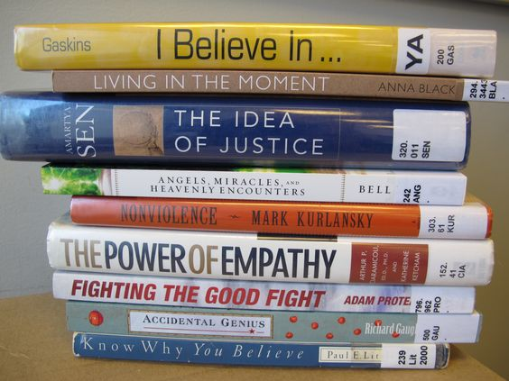  Asking Questions: Readers ask questions so they can learn more about one another's thinking.  Asking Follow-up Questions: Readers ask follow-up questions so they can get further information about something they asked about.  Requesting Evidence: Readers ask other group members to support their thinking with evidence by asking what made them think that.  Noticing What Made the Text Interesting: Readers notice how the writer made the text interesting to readers so they can understand more about how writers craft their stories. (Source: Figure 20-9. Getting Started: The First 35 Days, Fountas and Pinnell, Comprehension and Fluency)
    - Sources:
  Fountas & Pinnell, Teaching for Comprehension and Fluency, 2005
  Kelly Gallagher & Penny Kittle, 180 days, 2018
  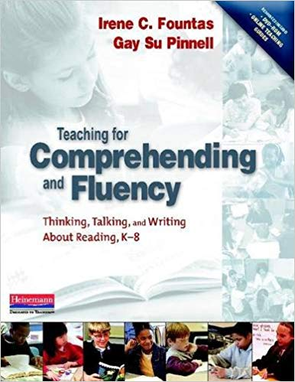
  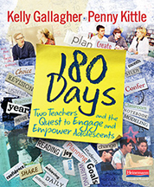
    - The Value of Talk:
  “Talk deepens thinking and learning. Yes there are moments when we seek deep, reflective silence in our classrooms, but these moments are balanced by the frequent buzz that occurs when students share interesting thinking with each other…
  We work to place talk in the center of our classrooms.”
  Kelly Gallagher & Penny Kittle, 180 days, 2018
    - Choice Drives Engagement:
  “We agree with Carol Ann Tomlinson and Susan Demirsky Allan, that students should have choice in at least one of these factors with every assignment: content, process, product or conditions for learning…
  Students are more likely to invest in the deep thinking needed for intellectual growth when given choice.”
  Kelly Gallagher & Penny Kittle, 180 days, 2018
    - Beauty in Content:
  “We believe in the value of reading and writing for their own sake, and we know there is a wide range of novels that will create an urgency to read...
  We strive to create classroom conditions that support discovery, persistence, and connection with writers in the room and writers they meet in the books they read.”
  Kelly Gallagher & Penny Kittle, 180 days, 2018
    - Listening:
  “We teach students to listen carefully and consider what a person said and did not say in a conversation, and to build on each other’s thinking when they discuss their book.”
  Kelly Gallagher & Penny Kittle, 180 days, 2018
    - Audience:
  “Engagement is often fueled by audience…
  We mix our students together to talk (through writing) in virtual book clubs and writing groups…
  We also extend the talk to even bigger audiences. We plan for students to create digital compositions, record dramatic readings of literary passages, record podcasts and other projects—all designed to be viewed or heard by broader audiences.”
  Kelly Gallagher & Penny Kittle, 180 days, 2018
    - Assessment:
  “We believe in grading less and assessing more…
  Grades tell us where our students ended up, but assessment—the key ingredient in responsive teaching—tells us where we are going.”
  Kelly Gallagher & Penny Kittle, 180 days, 2018
    - Conversation Moves:
  “I really agree with the point you brought up…
  I would like to hear your thoughts about…
  I agree with you comment and I am also wondering…”
  Kelly Gallagher & Penny Kittle, 180 days, 2018
    - Sources:
  Fountas & Pinnell, Teaching for Comprehension and Fluency, 2005
  Kelly Gallagher & Penny Kittle, 180 days, 2018
    - Habits of Mind for success:
  Curiosity
  Openness
  Engagement
  Creativity
  Persistence
  Responsibility
  Flexibility
  Metacognition
  “These habits are ways of approaching learning that are both intellectual and practical and will support student’s success in a variety of fields and disciplines.”
  Kelly Gallagher & Penny Kittle, 180 days, 2018
  Kate Carlisle, Living Sky School Division No. 202, September, 2018
  Title | Week 1 | Week 2 | Week 3 | Week 4
  Book 1 | p. 15 | p. 34 | p. 60 | finished
  Book 2 | p. 12 | p. 30 | p. 50 | finished
  Book 2 | p. 10 | p. 22 | p. 38 | finished
  Prepare | Read, think, mark | Students read during readers workshop and/or at home on the days preceding their book club meeting and think about what they want to discuss, documenting their thinking by marking the text with sticky notes, using a “think mark” (a bookmark that records page numbers, or another form of note-taking such as a Thought log or reader’s notebook
  Discuss | Talk and listen | For 20 to 30 minutes students share their thinking through talk, listening to others, adding to or challenging the thinking of others, or asking questions; supporting their thinking with personal experience or evidence from the text.
  Evaluate | Summarize and reflect | Students make summary comments and briefly evaluate what went well in the group. They set goals for how they can improve in book club discussion. If they need to read more, they make plans for how much more to read and when to meet. (see sample checklist)
  Extend (optional) | Extend | Students may be asked to reflect in writing to extend and demonstrate their thinking after reading and discussing the text. Occasionally members of the book club may create a larger project to share their thinking with others in the class.
  Exposition | Rising Action | Turning Point | Resolution
  Who is here? | What trouble is brewing? | What is changing? | What loose ends are tied up?
  How are the characters connected? | Where are the obstacles? | What is driving the change? | How are characters affected by the change?
  What are the characters like? | How do the characters deal with them? | Who wins the conflict? | How will life change?
  What kind of place is this? | How do the characters interact? | How is the problem / conflict resolved?
  What’s the trouble? | What’s the impact of setting on character, plot and conflict?

