An Updated Guide to Questioning in the Classroom
by TeachThought Staff

October 24, 2019

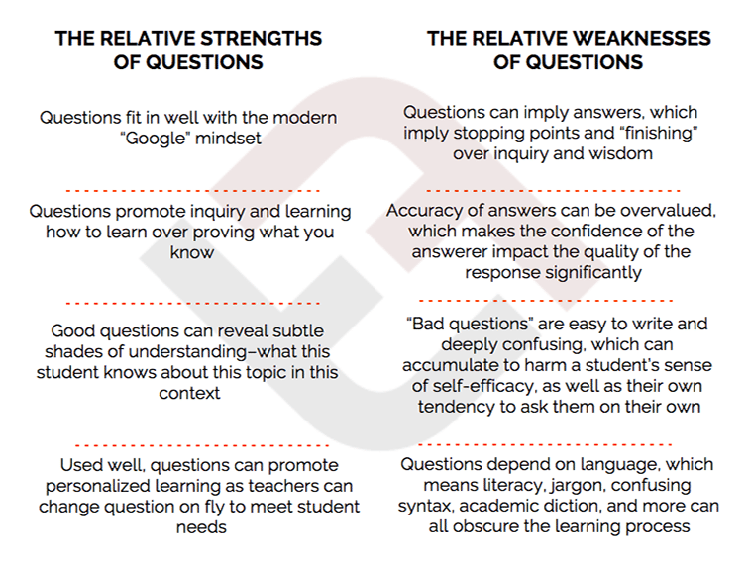
An Updated Guide to Questioning in the Classroom
by TeachThought Staff
Something we’ve become known for is our focus on thought, inquiry, and understanding, and questions are a big part of that. We’ve done questions that students should ask, parents should ask, students should and shouldn’t answer, questions that promote and stifle inquiry, questions that reveal self-knowledge and wisdom, and more.
If the ultimate goal of education is for students to be able to effectively answer questions, then focusing on content and response strategies makes sense. If the ultimate goal of education is to teach students to think, then focusing on how we can help students ask better questions themselves might make sense, no?

Why Questions Are More Important Than Answers
The ability to ask the right question at the right time is a powerful indicator of authentic understanding. Asking a question that pierces the veil in any given situation is itself an artifact of the critical thinking teachers so desperately seek in students, if for no other reason than it shows what the student knows, and then implies the desire to know more.
Asking a question (using strategies to help students ask better questions, for example) is a sign of understanding, not ignorance; it requires both knowledge and then–critically–the ability to see what else you’re missing.

Questions are more important than answers because they reflect both understanding and curiosity in equal portions. To ask a question is to see both backward and forward–to make sense of a thing and what you know about it, and then extend outward in space and time to imagine what else can be known, or what others might know. To ask a great question is to see the conceptual ecology of the thing.

In a classroom, a student can see a drop of water, a literary device, a historical figure, or a math theorem, but these are just fragments that are worthless in and of themselves. A student in biology studying a drop of water must see the water as infinitely plural–as something that holds life and something that gives life. As a marker of life, and an icon of health.
It is a tool, a miracle, a symbol, and a matter of science.
They must know what’s potentially inside of a drop of water, and then how to find out what’s actually inside that drop of water.
They must know what others have found studying water, as well as what that drop of water means within the field of science, and beyond it.
They must know that water is never really just water.
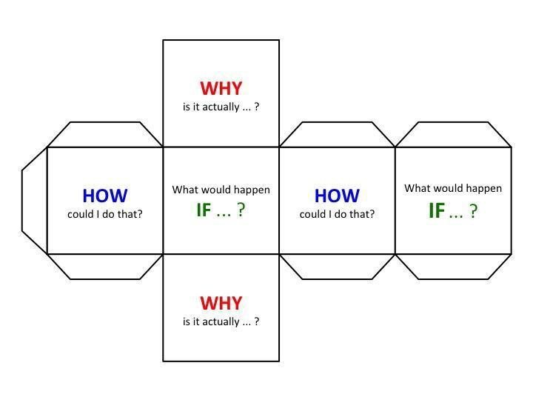Teacher Questions vs Student Questions
When teachers try to untangle this cognitive mess, they sacrifice personalization for efficiency. There are simply too many students, and too much content to cover, so they cut to the chase.
Which means then tend towards the universal over the individual–broad, sweeping questions intermingling with sharper, more concise questions that hopefully shed some light and cause some curiosity. In a class of 30 with an aggressively paced curriculum map and the expectation that every student master the content regardless of background knowledge, literacy level, or interest in the material, this is the best most teachers can do.
This is only a bottleneck, though, when the teacher asks the questions. When the student asks the question, the pattern is reversed. The individual student has little regard for the welfare of the class, especially when they’re forming questions. They’re on the clock to say something, anything. Which is great, because questions–when they’re authentic–are automatically personal because they came up with them. They’re not tricks, or guess-what-the-teacher’s-thinking.
A student couldn’t possibly capture the scale of confusion or curiosity of 30 other people; instead, they survey their own thinking, spot both gaps and fascinations, and form a question. This is the spring-loading of a Venus flytrap. The topic crawls around in the mind of the student innocently enough, and when the time is right–and the student is confident–the flower snaps shut. Once a student starts asking questions, that magic of learning can begin.
And the best part for a teacher? Questions reveal far more than answers ever might.
The Purpose of Questions
Thought of roughly as a kind of spectrum, four purposes of questions might stand out, from more “traditional” to more “progressive.” In What Is The Purpose Of A Question?, Terry Heick said: “To be a little more abstract, a good question causes thinking–more questions. Better questions. It clarifies and reveals. It causes hope. A bad question stops thinking. It confuses and obscures. It causes doubt.”
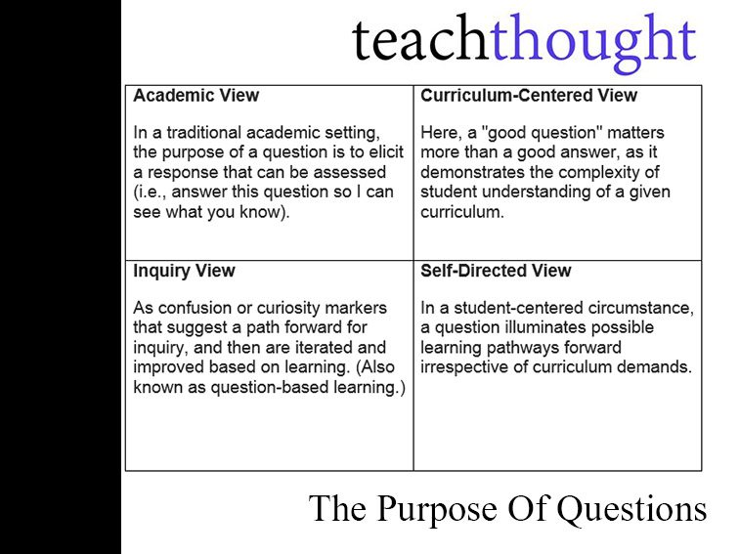
(More Traditional) Academic View
In a traditional academic setting, the purpose of a question is to elicit a response that can be assessed (i.e., answer this question so I can see what you know).
(Less Traditional) Curriculum-Centered View
Here, a “good question” matters more than a good answer, as it demonstrates the complexity of student understanding of a given curriculum.
(More Progressive) Inquiry View
As confusion or curiosity markers that suggest a path forward for inquiry, and then are iterated and improved based on learning. (Also known as question-based learning.)
(More Progressive Still) Self-Directed View
In a student-centered circumstance, a question illuminates possible learning pathways forward irrespective of curriculum demands. The student’s own knowledge demands–and their uncovering–center and catalyze the learning experience.
To be a little more abstract, a good question causes thinking–more questions. Better questions. It clarifies and reveals. It causes hope. A bad question stops thinking. It confuses and obscures. It causes doubt.
The Relative Strengths of Questions
- Good questions can reveal subtle shades of understanding–what this student knows about this topic in this context
- Questions promote inquiry and learning how to learn over proving what you know
- Questions fit in well with the modern “Google” mindset
- Used well, questions can promote personalized learning as teachers can change question on fly to meet student needs
The Relative Weaknesses of Questions
- Questions depend on language, which means literacy, jargon, confusing syntax, academic diction, and more can all obscure the learning process
- Questions can imply answers, which imply stopping points and “finishing” over inquiry and wisdom (See questions that promote inquiry-based learning.)
- Accuracy of answers can be overvalued, which makes the confidence of the answerer impact the quality of the response significantly
- “Bad questions” are easy to write and deeply confusing, which can accumulate to harm a student’s sense of self-efficacy, as well as their own tendency to ask them on their own
7 Common Written Assessment Question Forms
Questions as written assessment (as opposed to questions as inquiry, questions to guide self-directed learning, or questions to demonstrate understanding) most commonly take the following forms in writing:
- Matching
- True/False
- Multiple Choice
- Short Answer
- Diagramming
- Essay
- Open-Ended
Questioning & Self-Directed Learning
For years in classrooms, questions have guided teachers in the design of units and lessons, often through the development of essential questions that all students should be able to reasonably respond to, and that can guide their learning of existing and pre-mapped content.
In the TeachThought Self-Directed Learning Model, learners are required to create their own curriculum through a series of questions that emphasize self-knowledge, citizenship, and communal and human interdependence. In this model, existing questions act as a template to uncover potential learning pathways.

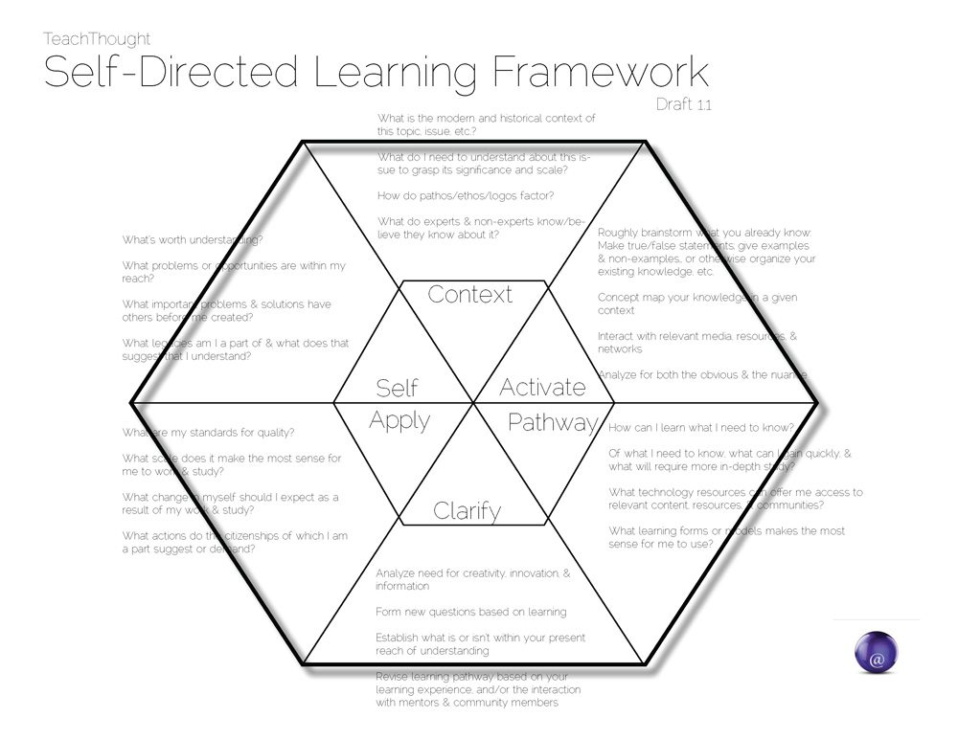

Cognitive Dissonance
Cognitive Dissonance is the cognitively uncomfortable act of holding two seemingly competing beliefs at the same time. If you believe that Freedom of Speech is the foundation of democracy, but then are presented with a perspective (through Socratic-style questioning from the teacher, for example), you arrive (or the student does) at a crossroads where they have to adjust something–either their belief, or their judgment about the validity of the question itself.
In this way, questions can promote Cognitive Dissonance–which means a good question can change a student’s mind, beliefs, or tendency to examine their own beliefs. Questions, cognitive, and self-reflection go hand-in-hand.
Role of “Lower-Level” Questions
Lower-level questions are questions that inquire at “lower levels” of various learning taxonomies.
These are often “recall,” questions that are based in fact—definitions, dates, names, biographical details, etc. Education is thought to have focused (without having been there, who knows for sure?) on these lower levels, and “low” is bad in academics, right? “Lower-level” thinking implies a lack of “higher level” thinking, so instead of analyzing, interpreting, evaluating, and creating, students are defining, recalling, and memorizing, the former of which make for artists and designers and innovators, and the latter of which make for factory workers.
And that part, at least, is (mostly) true. Recall and memorization aren’t the stuff of understanding, much less creativity and wisdom, except that they are. Bloom’s Taxonomy was not created to segregate “good thinking” from “bad thinking.” In their words, “Our attempt to arrange educational behaviors from simple to complex was based on the idea that a particular simple behavior may become integrated with other equally simple behaviors to form a more complex behavior.” In this way, the taxonomy is simply one way of separating the strands of thinking like different colored yarn–a kind of visual scheme to see the pattern, contrasts, and even sequence of cognitive actions.
Nowhere does it say that definitions and names and labels and categories are bad–and if it did, we’d have to wonder about the taxonomy rather than assuming that they were. It doesn’t take much imagination to see that if a student doesn’t know there was a war, and that it was fought in the United States in the 1800s, and that it was purportedly over states’ rights, and that both culture, industry, and agriculture all impacted the hows, whens, and whys of the war, that “higher-level thinking strategies” aren’t going to be very useful.
In short, lower-level questions can both illuminate and establish foundational knowledge on which to build more complex and nuanced understanding of content. They provide a foothold for thinking. To further the point, in 5 Common Misconceptions About Bloom’s Taxonomy, Grant Wiggins explains that the phrases “higher-order” and “lower-order” don’t appear anywhere in the taxonomy.
Essential Questions
Grant Wiggins defined an essential question as those that are “broad in scope and timeless by nature. They are perpetually arguable.”
Examples of Essential Questions
- What is justice?
- Is art a matter of taste or principles?
- How far should we tamper with our own biology and chemistry?
- Is science compatible with religion?
- Is an author’s view privileged in determining the meaning of a text?
- A question is essential when it:
- causes genuine and relevant inquiry into the big ideas and core content;
- provokes deep thought, lively discussion, sustained inquiry, and new understanding as well as more questions;
- requires students to consider alternatives, weigh evidence, support their ideas, and justify their answers;
- stimulates vital, on-going rethinking of big ideas, assumptions, and prior lessons;
- sparks meaningful connections with prior learning and personal experiences;
- naturally recurs, creating opportunities for transfer to other situations and subjects.
You can see more examples of essential questions here.
On Tuesday, we’ll help you take this background information and channel into specific question strategies that you can use to help students learn to create their own questions.

50 Examples Of Analogies For Critical Thinking
BY TEACHTHOUGHT STAFF
DECEMBER 16, 2019
5.4K
By forcing students to distill one relationship in order to understand another, it's almost impossible to solve analogies without understanding.

