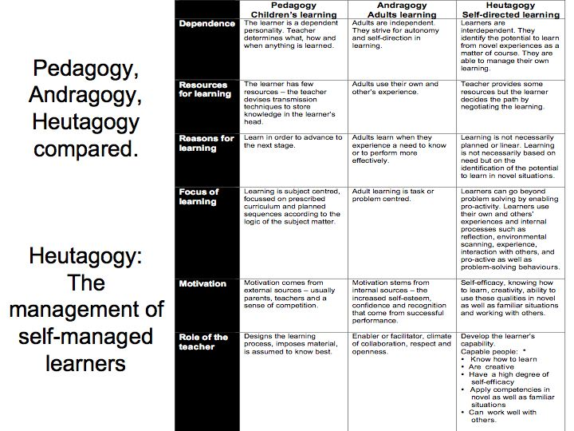
http://www.educatorstechnology.com/2013/11/interesting-chart-outlining-differences.html

“Teaching adults: Is it different article” http://www.calpro-online.org/eric/docgen.asp?tbl=mr&id=111
Heutagogy Links:
http://www.psy.gla.ac.uk/~steve/pr/Heutagogy.html
http://www.irrodl.org/index.php/irrodl/article/viewFile/1076/2113
https://heutagogycop.wordpress.com/history-of-heutagogy/

Differences between pedagogy and andragogy from Wikipedia
Here are some of the main differences between pedagogy and andragogy
 | PEDAGOGY | ANDRAGOGY
LEARNER: | —The learner is dependent on the instructor, the teacher schedules all the activities; determining how, when and where they should take place  —Teacher is the one who is responsible for what is taught and how it is taught  —Teacher evaluates the learning | —Learner is self-directed and moves towards independence  —Learner is responsible for the learning  —Self-evaluation is seen
LEARNER'S EXPERIENCE | —There is little experience which could be gained from this kind of learning  —Method is didactic | —There is large quantity of experience gained  — Method used is problem solving,discussion, service-learning
READINESS TO LEARN | —Standardized curriculum set which will be based on societal needs | —Curriculum is more application based and it revolves around life
ORIENTATION TO LEARNING | —Here, it is a process of acquiring subject matter | —Here learning is for performing tasks and solving problems
MOTIVATION | —Motivation is by external pressure, and there is lot of competition for grades | —It is driven by internal motivation.Includes self-actualisation,self-confidence etc.
.

from Canadian Literacy and learning network

http://www.literacy.ca/

Seven Principles of Adult Learning
These principles show the differences between how children and adults learn. Are you using adult teaching principles in your teaching?
- Adults must want to learn They learn effectively only when they have a strong inner motivation to develop a new skill or acquire a particular type of knowledge.
Helping their children is a strong motivator for learners who are parents.
Getting a high school diploma or a good job is another strong motivator for adults.

- Adults will learn only what they feel they need to learn Adults are practical in their approach to learning; they want to know, “How is this going to help me right now?”
Be practical, be direct.

- Adults learn by doing Children learn by doing, but active participation is more important among adults.
Adults need to be able to use these skills immediately so that they see their relevance.

- Adult learning focuses on problems and the problems must be realistic Children learn skills sequentially. Adults start with a problem and then work to find a solution.
Begin by identifying what the learner can do, what the learner wants to do and then address the gaps and develop practical activities to teach specific skills.

- Experience affects adult learning Adults have more experience than children. This can be an asset and a liability.
Use the learners’ experience (negative or positive) to build a positive future by making sure that negative experiences are not part of their experience in your program.

- Adults learn best in an informal situation Children have to follow a curriculum. Often, adults learn only what they feel they need to know.
Involve adults in the learning process. Let them discuss issues and decide on possible solutions. Make the environment relaxed, informal and inviting.

- Adults want guidance Adults want information that will help them improve their situation or that of their children. They do not want to be told what to do. They want to choose options based on their individual needs.
Present options, not instructions.

Critique
Knowles himself changed his position on whether andragogy really applied only to adults and came to believe that "pedagogy-andragogy represents a continuum ranging from teacher-directed to student-directed learning and that both approaches are appropriate with children and adults, depending on the situation. Hanson (1996) argues that the difference in learning is not related to the age and stage of one's life, but instead related to individual characteristics and the differences in "context, culture and power" within different educational settings.
In another critique of Knowles' work, Knowles was not able to use one of his principles (Self-concept) with adult learners to the extent that he describes in his practices. In one course, Knowles appears to allow "near total freedom in learner determination of objectives" but still "intended" the students to choose from a list of 18 objectives on the syllabus. Self-concept can be critiqued not just from the instructor's point of view, but also from the student's point of view. Not all adult learners will know exactly what they want to learn in a course and may seek a more structured outline from an instructor. An instructor cannot assume that an adult will desire self-directed learning in every situation.
J.R. Kidd goes further by claiming that principles of learning have to be applied to lifelong development. He suggested that building a theory on adult learning would be meaningless, as there is no real basis for it. P. Jarvis even implies that andragogy would be more the result of an ideology than a scientific contribution to the comprehension of the learning processes.^{[23]} Knowles himself mentions that andragogy is a "model of assumptions about learning or a conceptual framework that serves as a basis for an emergent theory. There appears to be a lack of research on whether this framework of teaching and learning principles is more relevant to adult learners or if it is just a set of good practices that could be used for both children and adult learners

