**NBCHS VISION STATEMENT**

***Building community,***

***Inspiring success***

**PRINCIPAL’S MESSAGE**

Wow! 2019-2020 was definitely a year that will be recognized in history and talked about in many classrooms in the future. Covid-19 has forced us to become very user friendly with our technology. We have all learned how much we miss seeing and learning person to person rather than virtually. Overall, I was very pleased how our students, staff and families worked together to flatten the curve and ensure we all stayed healthy and safe.

As we enter the 2020-21 school year at NBCHS, I really hope to ensure we continue to grow and learn. I want every student to meet their potential and set themselves up to conquer their goals. I know we have it in us to endure and overcome any challenges we are faced with.

We are looking forward to seeing and working with students and families to make sure the 2020-21 school year fosters learning and prepares each student to reach their goals.

Welcome to the 2020-2021 school Year!

Jay Nichol

**NORTH BATTLEFORD COMPREHENSIVE HIGH SCHOOL BELIEFS**

**We as members of the Viking community believe in:**

Promoting student learning and striving for excellence throughout the educational process.

Exhibiting mutual respect in our learning community.

Valuing and accepting every person in our inclusive learning community.

Exercising our right to learn in a safe, caring and trusting environment.

Promoting the development of life-long, independent learners. Educating students through access to a comprehensive education. Accepting responsibility and being accountable for our words and actions.

**VIKING VALUES**

**N**eed to respect self, others and the environment

**B**e honest and show compassion, acceptance and empathy for everyone within our school

**C**ommitment to learning

**H**ealthy lifestyle choices

**S**afe learning environment

The goal of NBCHS is to encourage our students to be the best learners and citizens they can be. This calendar has been prepared to answer many of your questions. Please read it carefully and have your parents/guardians do the same

**Due to the ongoing COVID-19 pandemic, the regular bell schedule and Viking Time have been revised, please see the following new School Day Schedule.**



**STUDENTS ARE REMINDED TO RESPECT THE LEARNING OPPORTUNITIES OF OTHERS AND NOT BE DISRUPTIVE IN THE HALLS.**

Students are reminded that when they leave the building it is expected that they will return to their next class on time. When students abuse the unassigned time privilege they may be interviewed in the office by the administration and may have to attend supervised GUIDED STUDY classes during their unassigned time.

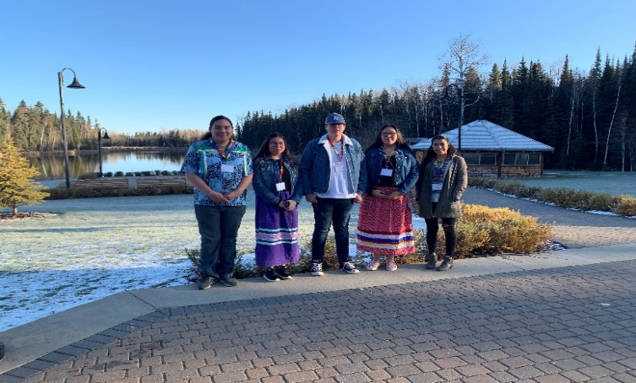

**STUDENT FEES**

Student fees are assigned to students and must be paid upon registration. Compulsory and option fees are indicated as follows:

S.R.C. Fee $ 20.00

Caution Fee (Refundable) $ 25.00

Lock Fee (New Students) $ 10.00

Yearbook (Optional) $ 45.00

Parking Permit $ 3.00

Other costs: Students shall be responsible for the costs of any supplies required in the subjects chosen.

Teachers will indicate fees early in each semester.

NOTE: Caution fees will only be refunded upon graduation or when a student moves to another school less any outstanding fees.

**EXTRA-CURRICULAR FEES**

Students may be charged fees dependent on the activity they join.

**P.O.P Program (Place of Positivity)**

Mental Health Capacity Building Initiative

Welcome to the P.O.P Program!! We are here to provide mental health promotion and education. Some things that you will see us doing at the school are; classroom presentations on a variety of topics, Mindful Mondays in our room to help you ease into the week, Courtyard activities, Non-school day activities like an open gym and just a chill place to be during a spare or at lunch plus so much more. If you are concerned about a mental health issue, we can help you find supports like the awesome counsellors in Student Services Office or other outside supports. Miss Stewart is your Mental Health Promotor and Mrs. Woytiuk is your Mental Health Coordinator and we are so excited to have another amazing year at NBCHS.

**RESOURCE CENTRE**

The aim of the NBCHS library is to provide a resource-based program which will allow students to acquire the information skills necessary for life-long learning. Our library contains a wide variety of curriculum-related materials that can help teachers teach their subjects and help students complete assignments based on those subjects. Students are encouraged to use the library, not only for study and research, but for the many recreational reading materials available. Students are asked to respect the rights of others using the library; that is to keep the noise level reasonable and return materials on time.

**Scholarships and Awards**

A considerable number of scholarships and awards are available to students graduating from NBCHS. Students are encouraged to apply for scholarships by contacting the Guidance Counsellors. Please read the announcements (and listen to announcements) for a current update of available scholarships.



[This Photo](http://www.nagpurtoday.in/) by Unknown Author is licensed under [CC BY-SA-NC](https://creativecommons.org/licenses/by-nc-sa/3.0/)

**NBCHS Graduation Awards:** The monetary awards given out at the graduation exercises are provided by businesses in the community and from interest earned on family donated (memorial) scholarship funds. NBCHS has a commitment to provide as many students as possible with monetary awards. The awards committee will determine the recipients based on the guidelines established and does its best to give each eligible winner the maximum amount of scholarship or bursary money available.

**Personal Counselling:**

School counselors will assist students and parents if difficulties arise with personal relationships and other matters which may affect behaviour and school performance. Students and parents are encouraged to contact the Student Services Office to resolve difficulties. All interviews are held in the strictest of confidence.

**Drug and Alcohol Counselling**

Counselling is provided for students suffering from addictions, as well as students who are affected by family members who use. Harm reduction is also addressed.

**School Liaison**

The school liaison works as a support for the students and families within the school. This includes helping with attendance, conducting home visits, referring to agencies within the community, the breakfast/lunch program and working to enhance the student’s lives with groups and other programming. This includes the P.A.R.T.Y. Program, Journey to Wellness Group (Partnered with Battle River Treaty 6 and others). Other services may include transportation to appointments, setting up team meetings, organizing awareness days and school speakers. Contact the Student Services Office to connect with the Liaison worker.

**High School Liaison Officer**

The job of the High School Liaison Officer is to bridge the gap between our youth and law enforcement. The Constableprovides educational information to our students in the form of presentations in areas such as drug use, community safety, as well as individual counselling and investigations as relates to this position. This is a project that has proven to be an important part of the school community.

**Career Counselling**

Students may obtain the most recent information on universities, technical institutes, training programs and other post-secondary institutions. Students can also arrange to take an interest inventory which helps them to understand their general work and career interest. The inventory will suggest various career and work options available to individuals

**School Matters**

Students can obtain information about the school, guidance in subject time-tabling and suggestions on how to improve their study and work habits. If, for whatever reason, you are experiencing difficulties and problems which are preventing you from getting the most out of your education and school life, please see a counsellor in the Student Services Office.

**SYA**

SASKATCHEWAN YOUTH APPRENTICESHIP is a provincial program available to all High School students enrolled in Technical/Vocational courses. Students can earn hours towards post-secondary training in the Trades and receive many other benefits from being a part of the program. More information is available from the Student Services Office.

**Apprenticeship**

Allows High School students the opportunity to earn Apprenticeship and Career Work Experience credits while working on a job site. Students are still registered at NBCHS but complete these credits in the community. Students wishing to take part in this program should contact the Student Services Office for further information.

**EXTRA-CURRICULAR**

Students are encouraged to take advantage of the many Extra-Curricular activities provided at NBCHS. There are many different STUDENT ACTIVITIES available to meet the many needs of our students. Students are reminded that for ALL STUDENT ACTIVITIES, the STUDENT comes first. Students must meet their student obligations in order to participate in the activities. These duties include but are not limited to: REGULAR ATTENDANCE, COMPLETION of ASSIGNMENTS, and APPROPRIATE BEHAVIOUR.

**STUDENT CONDUCT CODE**

All student conduct should be based upon common sense, respect for all individuals and behavior which is civilized and responsible. We expect all students to follow established school rules. We cannot and will not tolerate defiance of any school authority or acts of violence or intimidation towards others.

**NBCHS STUDENT ACCEPTABLE USE POLICY FOR COMPUTERS AND THE INTERNET FOR EDUCATION PURPOSES**

1. The NBCHS computer network has been established for a specific educational purpose. The term “educational purpose” includes classroom activities, career development and limited self-discovery activities.

2. The NBCHS network has not been established as a public access service or a public forum. NBCHS has the right to place reasonable restrictions on the material accessed or posted through the system. Students are expected to follow the rules set forth by the law and NBCHS (disciplinary code) on the use of the NBCHS network.

3. Students may not use the NBCHS network for commercial purposes. Students may not offer, provide or purchase products or services through the NBCHS network.

**Information about User Accounts for Students and Parents**

**Student Information**

At registration, a Living Sky account is created for students which can be used to

sign into school computers, school email, and connected services such as

Edsby.

**Edsby and Student E-mail access is found on the NBCHS web page** [**www.nbchs.lskysd.ca/**](http://www.nbchs.lskysd.ca/)

**Parent Information**

Parents can use the Edsby website to track their child’s marks and attendance. Information about how to gain access to this service is found on the NBCHS Homepage.

**\*Please also note that each student account is provided with $5 worth of printing at the beginning of the year. (Cost per page: 1¢ for black & white, 5¢ for colour). Any printing above this amount is the student’s responsibility.**

**Student Internet Access**

1. All students will have access to the Internet through their classroom, library, or school computer lab.

2. Access to Internet resources will allow access to web-based e-mail accounts. Procedures and times regarding personal e-mail use will be determined by departments. The school may grant use of NBCHS e-mail accounts when required for a specific classroom related activity.

3. If approved by the school, students may create a personal Web page on the NBCHS System. All materials placed on a Web page must be pre-approved in a manner specified by the school. Students will not be allowed to store personal, non-educational Web pages in the server.

4. The school may at any point limit access to on-line resources.

**Unacceptable Computer/Internet Uses**

**1. Personal Safety**

a) Students will not post personal contact information about themselves or other people. Personal contact information includes addresses, telephone numbers, school or work address.

b) Unless they have their parent’s permission students will not meet with someone they have met online.

c) Students will promptly disclose to their teacher or other school employee, any message they receive that they believe is inappropriate or makes them feel uncomfortable.

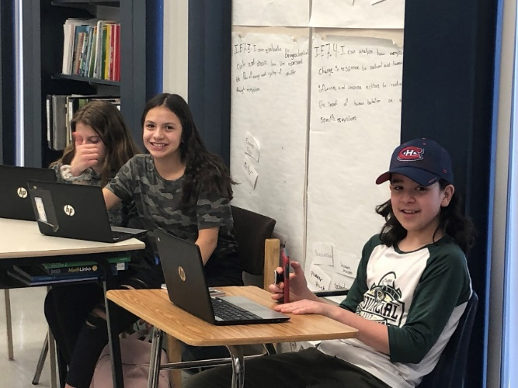

**2. Illegal Activities**

a) Students will not use the NBCHS computer network to engage in any illegal act. The school will report illegal activities to the RCMP and co-operate in any investigation related to possible illegal activities.

b) Students will not attempt to gain unauthorized access to the NBCHS system or to any other computer network through the NBCHS system or go beyond their authorized access. This includes unauthorized attempts to log in through another person’s account or access another person’s files. These actions are illegal, even if only for the purpose of “browsing”. Students are responsible for all activities occurring on their account.

c) Students will not deliberately attempt to deny services to any users of the NBCHS network. These actions are illegal.

d) Students will respect copyright laws. If a work contains language that specifies appropriate use of that work, the expressed requirements should be followed. If a student is unsure whether or not a work can be used, permission should be requested from the copyright owner.

**3. Inappropriate Communications**

NBCHS reserves the right to restrict content of any public or private messages and any material posted on Web Pages. Students will not use inappropriate language in any communication via the NBCHS network.

Students will not send communication that will damage the reputation of any other person, nor will they harass any other person.

**4. Plagiarism**

Students will not plagiarize works that they find on the Internet. Plagiarism is taking the ideas or writings of others and presenting them as if they were your own.

**5. Access to Inappropriate Material**

Students will not use the NBCHS network to access material that is profane or obscene (pornography), that advocates illegal acts, or that advocates violence or discrimination towards other people (hate literature). An exception may be made for these materials by teachers for the purpose of research. Parents may request alternate topics or assignments.

If a student mistakenly accesses inappropriate information, he or she should immediately inform a teacher or staff member. This will protect students against a claim of having intentionally violated the policy.

**Consequences -** Students found abusing or in violation of acceptable use policy may have their privileges limited or removed completely.

**SAFE ATTENDANCE**

Safe Attendance focuses on the health of students and staff before and while they are at school.

If students or staff are ill, they should remain at home.

• All staff and student will be asked to self-monitor for symptoms and use the online Saskatchewan COVID -19 Self-Assessment Tools.

• If students or staff members become ill while at school, they will be isolated at the office while family is contacted for immediate

pick-up.

**COVID-19 PROTOCOLS**

Entering the Building

1. Covid screening questions you will ask yourself each day:

Do you have any of the following symptoms?

* Fever
* New onset (or worsening of chronic) cough
* Shortness of breath or difficulty breathing
* Sore throat

Have you been outside of Canada, including the United States in the past 14 days?

Have you had close contact with a confirmed or probable case of Covid-19?

If you answer yes to any of the above questions, you should NOT enter the building. Call 811 for further instructions from Sk. Health.

2. Enter the door closest to the classroom you are going to (bus entrance, main doors, and north doors will be open)

3. Avoid clustering in groups

4. Masks are required when entering the school

5. Hand sanitize as soon as you enter

6. Proceed directly to your class

7. Enter at the appropriate time for your class

**MASKS:**

1. Masks will be worn prior to entering the school

2. Proper handling of masks which means not sharing, washing them or replace disposable ones daily

3. Neck gaiters and bandanas can NOT be worn, and masks must be school appropriate.

**CLASSROOM PROCEDURES:**

1. Masks are worn unless physical distance can be maintained

2. Teachers may allow mask breaks

3. Hand sanitize when entering the classroom

4. Seating plan: teachers will have assigned seating that must be followed (contact tracing)

5. Wash/sanitize hands regularly and keep them away from your face

6. Clean/sanitize your space before leaving

7. Bring own water bottles as fountains will only be used for filling stations

8. If you are feeling ill at school, arrangements will be made for a safe pick up

**STUDENTS LEAVING SCHOOL MID-SEMESTER (after Sept 30)**

1. Any student leaving school in mid-semester, MUST see an administrator to obtain a clearance form.
2. The student must have each of the subject teachers and library sign the form and return any books to the teacher and library.
3. Caution fees will be refunded only after we are assured that no books are missing or still charged to the student.
4. Final clearance and refund of caution fees will be handled by the office.

**ACCIDENTS**

Schools, like any other place, are not accident free. If an accident should occur, it must be reported to the office. If necessary, the family doctor will be contacted, or the student will be taken to the hospital and the parents will be notified.

**VEHICLE COLLISIONS WILL BE THE RESPONSIBILITY OF THE DRIVERS AND OWNERS.**

**STUDENT ATTIRE**

Students are expected to support standards of dress reflecting the school’s purpose as a place of learning and work as well as the values and expectations of a school community. Dress so that you will not be asked to change or asked to go home and change. When in question, a referral will be made to the school administration. Standards of grooming and dress are determined from the perspectives of health and safety in all activities, cleanliness and neatness, and decency and respect. Students may be asked to change into more appropriate apparel if they have:

* Any exposure of the trunk of the body (front, sides, back, belly)
* Visible undergarments
* Low slung pants and tanks
* Pictures or words on clothing that are indecent or disrespectful to others
* Bandanas must not be worn on school property. They are considered gang symbols and are used by gangs for identification. HOODS must not be worn inside the school building. Staff must be able to see a student’s face for identification purposes. Students must wear appropriate footwear and clothing for indoor activities and physical education.

**STUDENT PARKING**

PARKING PERMITS are available to Grade 11 and 12 students on a “first come, first served” basis; Grade 9 and 10 students are not guaranteed parking permits. Students are permitted to park vehicles only in designated student parking areas. The school cannot assume responsibility for damages to student vehicles. Students are not permitted to park within the staff parking lots of NBCHS and NWRC Staff. **STUDENTS THAT REQUEST HANDICAP PARKING MUST MAKE ARRANGEMENTS WITH THE ADMINISTRATION FOR THIS ASSIGNMENT.**

**TELEPHONE CALLS AND MESSAGES**

Because of the difficulty and disruptions which occur in locating students, telephone calls and messages will be taken only in case of emergency.

**TEXTBOOK POLICY**

Textbooks, where required, will be provided on loan to each student at the beginning of each semester. Students are responsible for each textbook and are required to return all books at the end of the semester or when he/she discontinues school. A caution fee of $25.00 must be paid upon registration and will be refunded when all textbooks and other school property are returned in acceptable condition at the end of grade 12 or if moving to another school. Students who lose textbooks will be charged the cost of a new book.

**LOST AND FOUND**

The Board of Education cannot carry insurance for loss or theft of personal property. Students should clearly mark or identify all personal possessions so that they may be more easily traced.

Lost and Found located in the Student Services Office (SSO)

**STUDENTS VISITING OTHER SCHOOLS**

Students should be aware that they are not allowed to visit other schools during the school day. The education law indicates that this is TRESPASSING. Students are not allowed to bring non-students on the property without the permission of the administration.

**OPEN CAMPUS POLICY**

North Battleford Comprehensive High School has an open campus policy meaning students have the choice to go off campus during lunchtime, but will not be able to reenter the school until the afternoon classes start. Students are expected to follow the rules and laws of the businesses they frequent and the community at large.

**LUNCH/CAFETERIA**

1. All students are encouraged to leave the school if possible.

2. Cafeteria is open to purchase food following protocols: food and utensils will be handed out.

3. Students who receive the lunch program can pick up bag lunches from Sam at the cafeteria till area, do not wait in the lineup.

4. All students will eat their lunches in the classroom unless there is a designated area in the cafeteria.

5. Students will remain in the classroom after eating for the duration of the lunch hour.

Students who stay in the school during lunch hour are required to eat in the designated areas.

We ask that all students help keep the cafetorium clean by getting rid of their own garbage, returning the trays, pushing in their chairs, etc.

**HALLWAYS:**

1. To enable us to keep our corridors a clean and healthy environment, we ask that students do not consume food and drinks in the hallways.

2. Walk on the right side of the hallways

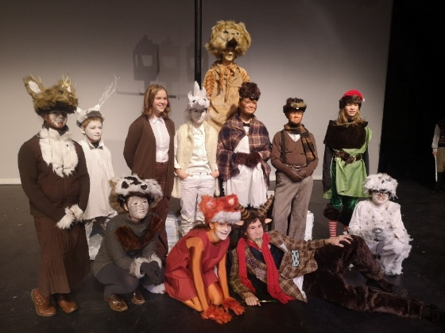3. Physical distance

4. Breaks will be organized by your classroom teachers

5. Washrooms: limited number and you will use the washroom closest to the classroom you are in

**OUTSIDE SCHOOL PROPERTY:**

1. Students who are observed littering outside will be reminded to clean up the mess.

2. Students are EXPECTED to dispose of garbage properly and return CANS and BOTTLES to the

RECYCLE containers inside the school.

**STUDENT PHONE POLICY**

1. There is a student phone located in the main office.

2. Students are permitted to carry cellphones, but phones MUST be turned off during class time. Students using cell phones during class time will have the phone confiscated and they may have to speak to an administrator in order to have their phone returned.

3. Students are not allowed to video staff or students in class or out of class without the approval of the classroom teacher or the administration. Posting video to the web without administration approval is prohibited for reasons of privacy.

**TOBACCO POLICY**

NBCHS is a smoke and tobacco free property. Provincial Law prohibits the use of tobacco products on any school property. Students observed using tobacco products on NBCHS shall face disciplinary action. This policy will include the use of any vapour pens or e-cigarettes on school property.

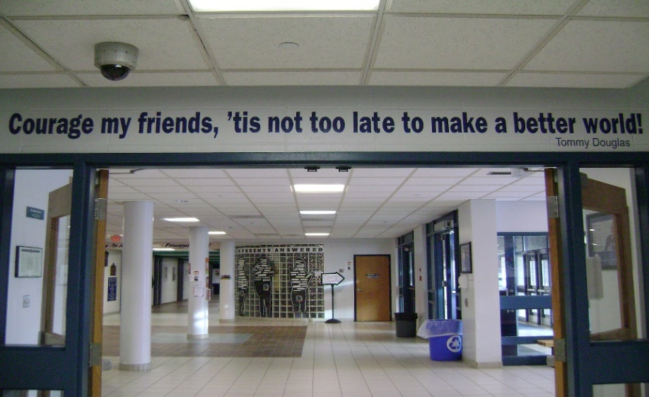**NORTH WEST COLLEGE**

North West College shares part of the NBCHS building. NBCHS students are asked to stay on the High School side of the building and not use the NWC entrances/exits.

**EVALUATION AND REPORT CARDS**

The evaluation and assessment process at NBCHS is continuous, cumulative, and comprehensive. All students will receive a course outline at the outset of each course describing the evaluation/assessment that will be used during the course.

Students in High School courses (Grades 10-12) will receive percentage grades. Students must achieve 50% or higher in order to earn the credit and move on to the next course level. Mastery achievement levels of certain skill sets and tasks may be determined by the teacher and be higher than 50%.

Students in the Middle Years program (Grades 7-9) will be assessed on the 1- 4 rubric.

Progress Reports will be issued at mid-term and at the conclusion of the semester. Parents should check **Edsby** regularly (see below). Although parent/student/teacher conferences are held after mid-term evaluation (November and April), parents are encouraged to follow the progress of their children closely and, if necessary, contact subject teachers if concerns arise.

**Grade XII Supplemental Exams**

Students shall have the opportunity to write a Ministry of Education examination. Ministry prepared examinations shall be written at the next official sitting (e.g. Semester I students may write in January; Semester II students may write in August.) For more information contact the Student Services Office.

**EDSBY**

Parents and students are encouraged to access marks and attendance through Edsby on the NBCHS webpage. Please contact the office if you require assistance setting up your account.

**GRADUATION REQUIREMENT:**

Students MUST fulfil the following criteria before your name will be placed on the PRELIMINARY GRAD LIST:

The student MUST have the potential to complete the 24 compulsory credits or the seven compulsory 20/30 level credits for Adult Status program.

The student MUST have a CREDIT CHECK completed by a counsellor in the Student Services Office.

The student MUST NOT have outstanding fees owing to NBCHS.

Any student who has outstanding school fees will not be allowed to participate in NBCHS graduation exercises unless COMPLETE payment has been received by the last school day in **MARCH** of the current school year.

Students who are failing REQUIRED credits at MID-TERM of semester two WILL BE removed from the GRAD LIST and placed on academic probation. Students may be reinstated to the GRAD LIST during the last week in May if THE STUDENT REQUESTS a REVIEW and has a PASSING mark in all REQUIRED subjects as of May 31st.

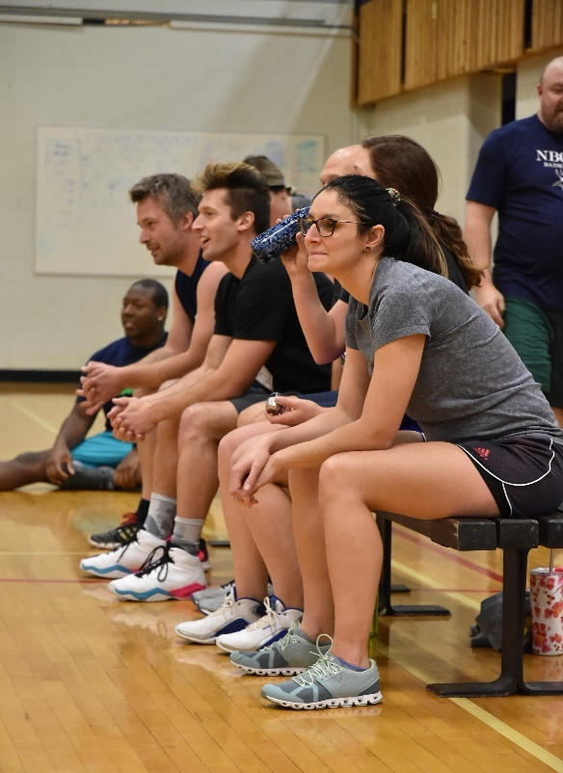STUDENTS REQUESTING REVIEWS during the last week of May will apply to MR. NICHOL at the Administration Office after May 31st.

If students DO NOT request a review by the end of the last week of May, they will be permanently removed from the GRAD LIST.

**GYMNASIUM**

Appropriate gym clothing is required for all physical education classes. Use of the gymnasium by students at any time requires the permission of a physical education teacher.

**LOCKERS ARE SCHOOL PROPERTY AND THE ADMINISTRATION RESERVES THE RIGHT TO INSPECT LOCKERS AT ANY TIME.**

Only school locks may be used, and a record of the combination must be kept in the office. Locks will be sold to students at cost price. Students may trade in an old NBCHS lock for a new one in place of this fee. Replacement for damaged or lost locks may be purchased from the office. Students enrolled in Physical Education classes will be assigned a locker in the gym.

**THE SCHOOL IS NOT RESPONSIBLE FOR ARTICLES MISSING FROM LOCKERS.**

Students are advised to make certain that lockers are locked and valuables are not left out in the open. Students will be required to clean out their lockers on the designated day at the end of June. The school will not be responsible for any articles left in the lockers after that time**. Students will be charged $5.00 if their lock is not removed by the deadline. Students will be assessed a $15.00 fee if lockers are not cleaned satisfactorily. Students will be charged $25.00 for damage to their locker.**

**USE AND ABUSE OF ALCOHOL OR DRUGS ON SCHOOL PROPERTY**

Any student who is found in possession of or under the influence of alcohol or drugs on school premises or during authorized school activities will be dealt with by administration. They will also be required to meet with our Addictions Counsellor and with the RCMP Liaison officer.

**NBCHS AWARDS SYSTEM**

The purpose of the Awards System is to give public recognition to those students who have made significant contributions to the North Battleford Comprehensive High School.

**AWARDS POINT SYSTEM PHILOSOPHY**

1. Participation and academic excellence are the major basis of points.

2. Grand Major, Major and Minor awards are based on 3 years of participation.

3. All points specified are maximum and points up to the maximum are granted at the discretion of Teacher Advisors/Coaches/ Supervisors.

**AWARDS**

1. Grand Major 230 plus points

2. Major 170-229 points

3. Minor 110-169 points

**ACADEMIC POINTS**

All averages for NBCHS Honor Roll, scholarships and bursaries will be calculated using Department of Education guidelines for Grade 10, 11, 12 credits.

1. 90%-100% - 5 points per subject, 7 points per subject for I.B. classes

2. 80-89% - 4 points per subject, 5 points per subject for I.B. classes

**PRINCIPAL’S HONOUR ROLL**

The North Battleford Comprehensive High School Honour Roll is designed to recognize student achievements in subjects taken during a school year. The Honour Roll will consist of two categories for regular academic subjects. Students with averages 80 – 84.9% will receive certificates for being on the school’s honor roll. Students with averages 85% – 100% will receive certificates specified honour roll with distinction. Honour roll is based on final marks of the first semester and midterm marks from the second semester. Students are advised that the criteria for selection to the Principal’s Honour Roll is calculated using the following regular subjects:

1. Grade 10 – English 10 (2 credits), Math 10, Science 10, Canadian Studies 10, plus one 10 level elective (6 credits)

2. Grade 11 – English 20, Math 20, a Science 20, a Social Science 20, plus one 20 level elective (5 credits)

3. Grade 12 – English 30 (2 credits), a Canadian Studies 30, a Math 30, a Science 30, plus one other 30 level elective in regular academic courses (6 credits)

The top academic achiever in grade levels 10 and 11 will receive the academic proficiency award/trophy, which will be recognized at the NBCHS Awards nights. The grade 12 award will be given out at the graduation ceremonies.

**SPECIAL RECOGNITION AWARDS:**

These are not Honour Roll Awards.

1. The school will recognize one student in each of grade 10, 11 and 12 with the highest academic achievement award who is taking modified 11, 21, 31 courses and other electives. Maximum five or six classes – depending upon the grade level.

2. The school will recognize the student in each of grade 10, 11 and 12 with the highest academic achievement in the courses offered at the 18, 28, 38 level based on their program.

3. The school will recognize students from each of grade 9, 10, 11 and 12 Special Education Functionally Integrated programs who have shown excellent improvement in their individualized programs.

**PRINCIPAL’S AWARD:**

The Principal’s Award is for students in grades 7-9. The student awarded this recognition is one who exemplifies the qualities of a great citizen, is inclusive of others both in the classroom and around the school, is a role model for his/her peers, exhibits perseverance, effort and strong academic ability or progress in the classroom, and is someone who the school staff and Principal feels is an excellent representative of our school.

**ACTIVITY CLUB POINTS**

Each student is encouraged to join one or more of the following SRC approved clubs. The maximum points are listed. The following will be taken in consideration: eligibility (attending regularly), where there is an executive, the executive member may receive up to five (5) points at the discretion of the Staff Advisor. Students will earn points as a Junior for Grade 7-9 and Senior Grades 10-12. Jr and Sr. points are not cumulative.

**1 POINT ACTIVITIES:**

• Store

• Cooking Club

• Golf

• Other clubs that meet once or twice (blood drive, food drive, etc.)

**5 POINT ACTIVITIES:**

• Mock Trial

• Baking Club

• Salt & Light

• Pottery

• Me to We

• Skills Canada

• Junior Badminton

• Cross Country

• Yearbook

• Grad Committees

**10 POINT ACTIVITIES:**

• SRC

• Debate

• Me – to – We

• Jazz Band

• Concert Band

• Choir

* Drama (per production)

• Junior Volleyball

• Junior Football

• Curling

• Soccer

• Senior Badminton

• Track & Field

**15 POINT ACTIVITIES:**

• Senior Volleyball

• Senior Basketball

• Junior Basketball

• Senior Football

Captains may earn an additional 5 points

• Teams/clubs representing

NBCHS at Provincial

competitions may earn an

additional 5 points

**ACADEMIC REQUIREMENTS AT NBCHS**

Students enrolled at NBCHS are required to enroll in classes according to the following criteria:

**Grade 7-9** students will register in the required program as set out by the Ministry of Education and NBCHS. Students ARE NOT allowed spares. Exceptions to this policy are at the discretion of the administration.

**Grade 10 Year**

1. Language Arts: one of the following: (2)

English 10/11 (A & B)

2. Mathematics: one of the following: (1)

Math 10/11 Foundations

Math 10/11 Workplace

3. Science: one of the following: (1)

Science 10/11

4. Social Studies: one of the following: (1)

Social Studies 10/11

History 10/11

Native Studies 10

5. Wellness 10 (1)

6. Arts Education/Practical and Applied Arts:

Minimum of two of the following: (2)

Music 10

Band 10

Art 10

Digital Photography 10

Drama 10

Welding 10

Accounting 10

Info Processing 10

Machining 10

Mechanics 10

Construction 10

Drafting 10

Cosmetology 10

Com Cooking10

Compulsory Credits 8

Elective Credits 2

Total Credits 10

**Grade 11 Year**

1. Language Arts: one of the following: (1)

English 20/21

2. Mathematics: one of the

following: (1)

Math 20/21 Foundation

Math 20 Pre-Calculus

Math 20/21 Workplace

3. Science: one of the

following: (1)

Health Science 20/21

Environmental Science 20/21

Physical Science 20

4. Social Sciences requirements may be met by taking one of the following: (1)

Social Studies 20/21

History 20/21

Psychology 20/30

Law 30

Compulsory Credits……….4

Elective Credits (AnyLevel)……….Minimum 5

Total Credits….….Minimum 9

**Grade 12 Year**

1. Language Arts: one of the following: (2)

English 30/31 (A & B)

Canadian Studies: one of the following: (1)

Social Studies 30/31

History 30/31

Native Studies 30

Compulsory Credits 3

Elective Credits (30 Level) 2

Open Electives Minimum 3

Total credits 8

**NOTE:** IB courses meet all requirements in same subject area. Please see academic advisor for specific graduation requirements.

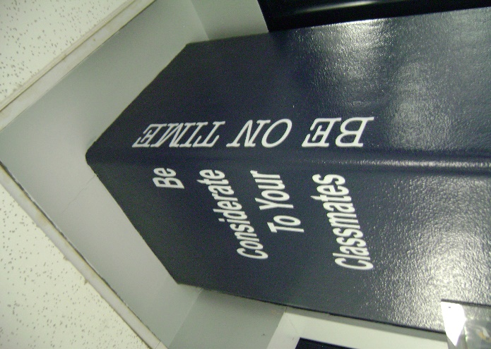

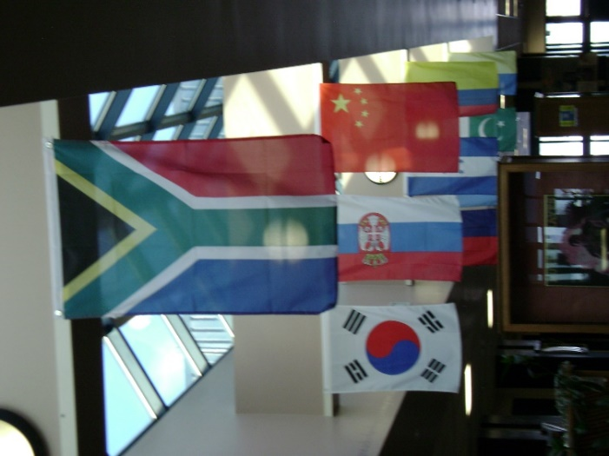

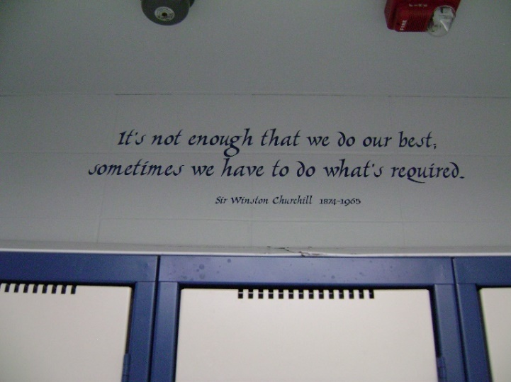

**Dates:**

**Sept 7th – Labour day**

**Sept 23rd – Early Dismissal**

**Sept 28th – PD Day (Non-Student Day)**

**Oct 12th – Thanksgiving**

**Oct 21st – Early Dismissal**

**Oct 26th – PD Day (Non-Student Day)**

**Nov 2nd – End of Block 1 for Grade 9-12**

**Nov 3rd – Summative Assessment**

**Marks due????**

**Nov 4th – Start of Block 2 for Grade 9-12**

**Nov 11th – Remembrance Day**

**Nov 18th – Early Dismissal**

**Nov 30th – PD Day (Non-Student Day)**

**Dec 3rd – Winter Concert ???**

**Dec 18th – Early Dismissal 2:30PM**

**Dec 19th to Jan 3rd – Christmas Break**

**Dec 24th – Christmas Eve**

**Dec 25th – Christmas Day**

**Dec 26th – Boxing Day**

**Dec 31st – New Year’s Eve**

**Jan 1st – New Year’s Day**

**Jan 4th – Students return**

**Jan 6th – End of Block 2 for Grade 9-12**

**Jan 7th – Summative Assessment**

**Marks Due ???**

**Jan 8th – Start of Block 3 for Grade 9-12**

**Jan 20th – Early Dismissal**

**Jan 29th – Non-Student Day**

**Feb 14th – Valentine’s Day**

**Feb 15th – Family Day**

**Feb 16th to Feb 19th – Winter Break**

**Feb 24st – Early Dismissal**

**Mar 4th – End of Block 3 for Grade 9-12**

**Jan 5th – Summative Assessment**

**Marks Due???**

**Mar 8th – Start of Block 4 for Grade 9-12**

**Mar 15th – PD Day (Non-Student Day)**

**Mar 17th – St. Patrick’s Day**

**Mar 24th – Early Dismissal**

**Apr 2nd – Good Friday**

**Apr 4th – Easter Sunday**

**Apr 5th – Easter Monday**

**Apr 5th to Apr 9th – Easter Break**

**Apr 21st – Early Dismissal**

**Apr 26th – PD Day (Non-Student Day)**

**May 4th – End of Block 4 for Grade 9-12**

**May 5th – Summative Assessment**

**Marks Due ??**

**May 6th – Start of Block 5 for Grade 9-12**

**May 19th – Early Dismissal**

**May 24th – Victoria Day**

**May 25th – PD Day (Non-Student Day)**

**May 27th – Spring Concert??**

**June 24th – End of Block 5 for Grade 9-12**

**June 25th – Graduation Day**

**June 28th – Summative Assessment**

**Marks Due???**

**June 29th – Non-Student day**

**June 30th – Non-Student day**