Creating Analogies

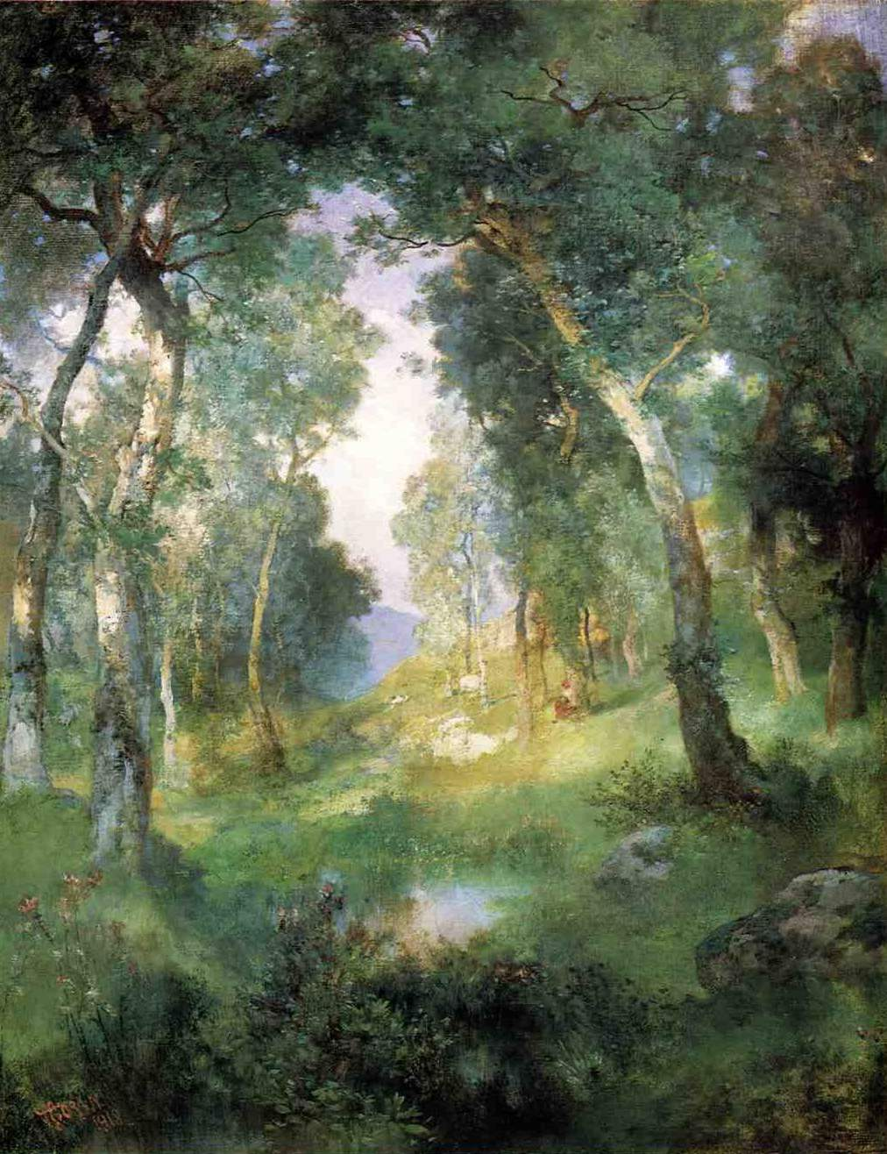
A Supportive Learning Environment is like a forest glade because
________________________________________________________________________________________________________________________________________________________________________________________________________________________________________________________________________________________________________________________________________________________________________________________________________________________________________________________________

