
https://www.teachthought.com/

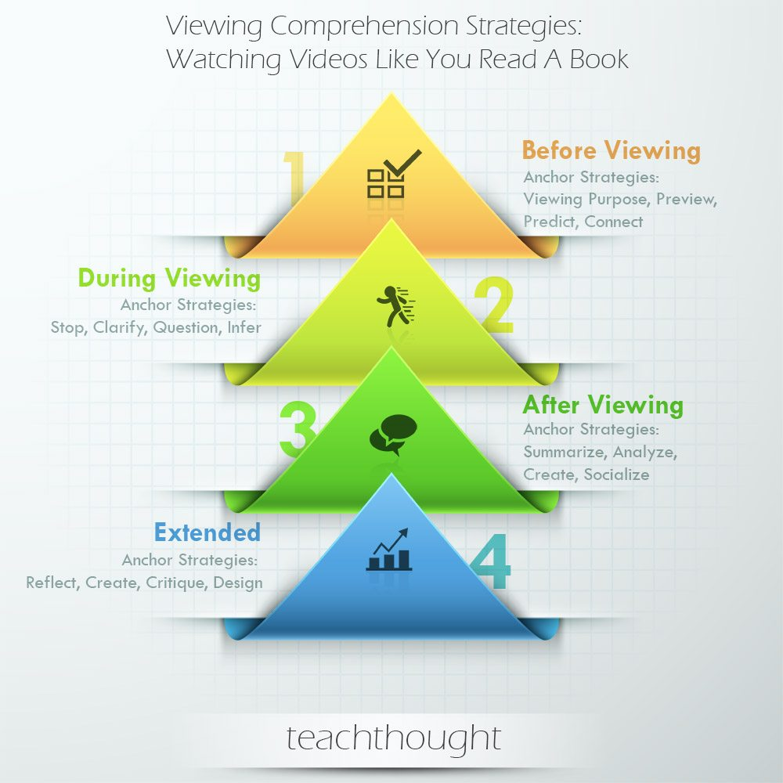

40 Viewing Comprehension Strategies That Help Students View Videos Like They Read Books
Before Viewing
Before viewing comprehension strategies that promote understanding of video and streaming content.
Anchor Strategies: Viewing Purpose, Preview, Predict, Connect
1. Set a viewing purpose
2. Predict (e.g., sequence of events, video creator’s position on a given topic, etc.)
3. Preview video (editing conventions, length, title)
4. Identify media connections (e.g., I read a book on a related topic recently; I saw a tweet that described this same idea but in sarcastic terms, etc.)
5. Make True/False statements about general video topic
6. Begin KWL chart
7. Roughly summarize (e.g., what they know about topic. video creator, channel, etc.)
8. Concept map the video topic in a given or self-selected context
9. Complete Anticipation Guide
10. Create self-produced guiding questions

During Viewing
During viewing comprehension strategies that promote understanding of video and streaming content.
Anchor Strategies: Stop, Clarify, Question, Infer
READ
21st Century Literacy: A Framework For Merging Classic…
Feb 28, 2018
Why Students Should Read
Feb 1, 2018
11. Stop (or pause) the video while viewing based on viewer preference and monitoring of own understanding
12. Rewind to clarify understanding or uncover subtle data/events
13. Rewatch video with new purpose and perspective
14. Form relevant questions based on viewing
15. Clarify (e.g., information, bias, fact/opinion, “author” position, etc.)
16. Monitor & Repair Understanding
17. Evaluate use of primary and secondary modalities
18. Make meaningful and personalized inferences (e.g., primary and secondary audiences)
19. Infer underlying assumptions of video
20. Adjust viewing speed (i.e., use slow-motion) if available (e.g., physics videos)

After Viewing
After viewing comprehension strategies that promote understanding of video and streaming content.
Anchor Strategies: Summarize, Analyze, Create, Socialize
21. Retell what happened; Paraphrase “standout” ideas
22. Summarize main idea and key supporting details
23. Recall own thinking and/or emotions during video (metacognition)
24. Modality Analysis (e.g., identify and analyze prevailing modalities and their effect)
25. Metric Analysis (e.g., to infer social context with respect to total views, currently watching, social shares, etc.)
26. Analyze idea organization of video
27. Create a word cloud (e.g., that reflects diction, tone, theme, etc.); Tweet, comment on, blog, or otherwise socialize initial impressions in a way that reflects digital citizenship
28. Socialize extended responses (e.g., in writing, on social media, etc.)
29. Categorize information and perspectives
30. Separate explicit and implicit ideas

Extended
Extended comprehension strategies are meant to provide extended learning around video and streaming content, as well as opportunities for more complex thinking about that content.
Anchor Strategies: Reflect, Create, Critique, Design
31. Reflect on “fit” of video with regards to Viewing Purpose
32. Compare & contrast video with similar video content
33. Create Anticipation Guide (for viewers that haven’t seen video)
34. Identify “big idea” of video
35. Critique video for which modalities supported video purpose and theme, and which seemed to distract
36. Roughly determine history of topic in similar and dissimilar media
37. RAFT thinking & extension (Role, Audience, Format, Topic/Theme)
38. Prioritize ideas & information from least to most important
39. Distinguish between tone and mood of video
40. Design follow-up medium that extends and deepens purpose of video

