Think about what you wonder about the book or another person’s ideas. How do different types of questions get at different information and keep the conversation going? What kind of questioner are you?

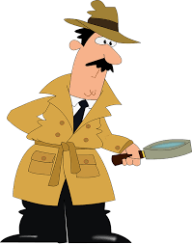
STARTER
Who?
What? Where? When?
What happened?

DETECTIVE
What do you think?
What do you mean?
Why? What caused?


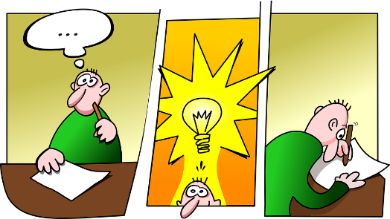
JUDGE
What evidence do you have?
Can you prove it?
How do you know?
Are you sure?

INVENTOR
What would you do if…?
What might happen if…?
If you were…?

Think about what you are wondering.
Think about what she just said. What can you ask to keep the conversation going?
Start with “Why…?”
Start with “How…?”
That is a statement. If you were to ask a question, What would it be?

