Read a chunk. Think, “What did I just read? What should I jot to help me remember?” Then, translate the author’s words into a symbol system to help you rmemer. These symbols will help you go back and quickly skim the information, which is important in nonfictions when there is often so much information packed together.
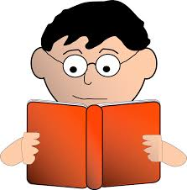
Read:
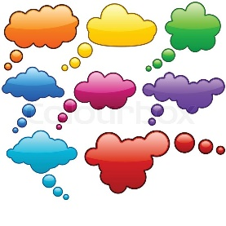
think: What did I just read? What will help me remember?
Choose a symbol:
BK Background Knowledge ? Confusion

C Connection Favourite part

Main idea E Evidence to support main idea
* Important ! Interesting or surprising
Prompts:
Think about what you just read. What symbol would you use to remind yourself?
Check the chart of symbols. How would you respond to this part?
Make sure you are reading just a chunk! Stop and jot.
Think of the words the author wrote. What is your response?
Go back and skim the symbols. Remind yourself of what you read
Make sure you know what you read before you move on.
Source: Source: Jennifer Serravallo, Reading Strategies Book Your Everything Guide to Developing Skilled Readers, Heinemann, 2015.
