Before reading, talk or write about what you know for sure, what you think you know and what you wonder. Then, read getting ready to learn new information.

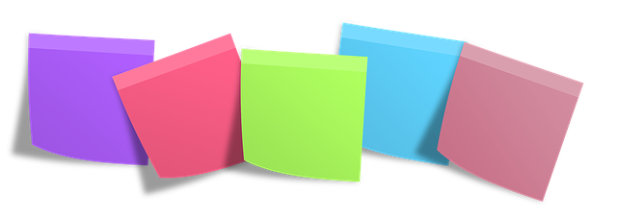

JOT OR SAY

What you KNOW FOR SURE

What you THINK you know

What you WONDER

Prompts:
You can start with, “I’m not sure, but I think…”
What is something you are sure you know? How are you sure?
What are you wondering about your topic?
What do you know a little about?
What do you want to learn about more deeply?
What are you learning, now that you’ve read this part?

Source: Jennifer Serravallo, Reading Strategies Book Your Everything Guide to Developing Skilled Readers, Heinemann, 2015.

