
- Jot down your wonderings


- Study your questions.
Is there a pattern?
What is the text mostly about?

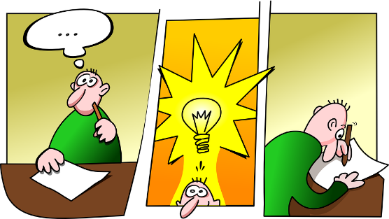
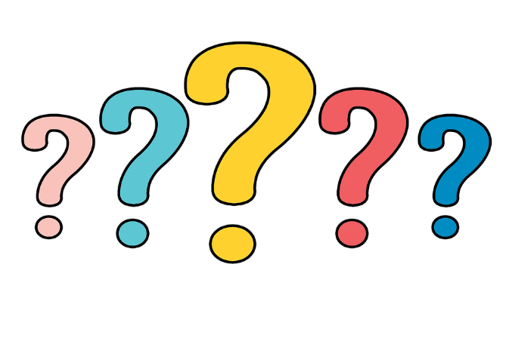
- Answer your questions

- Reflect on your ideas.
What is the main idea?

Wonder and question as you read. Work actively to answer your questions. Collect all the questions and answers as you go. Based on all of the questions and answers think “What does it seem like the text is mostly about?”
Prompts:
Jot what you are wondering.
Look back at all of your questions.
Reread your questions. Is there a pattern? What is the text mostly about?
Make sure to answer your questions, if you can.
Look at all you’ve written down. What’s the main idea?

Source: Jennifer Serravallo, Reading Strategies Book Your Everything Guide to Developing Skilled Readers, Heinemann, 2015.

