Elementary Online Resources
available from Living Sky School Division and the Saskatchewan Ministry of Education

Revised March 17, 2017

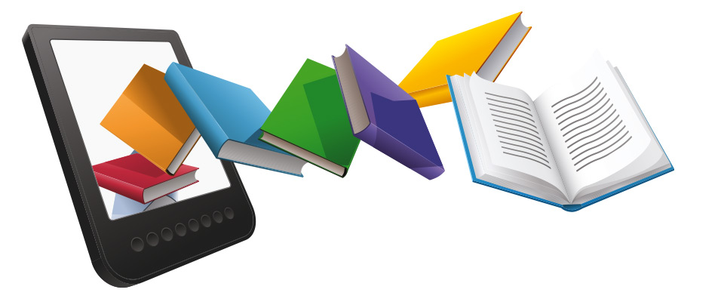

The goal of education is the advancement of knowledge and the dissemination of truth.
John F. Kennedy



Website: https://slz01.scholasticlearningzone.com/auth/intl/SBA/BKWWCA

School Access: from the School Library Website

Home Access from the School Library Website

Username & Password required
- Username: livingsky
- Password: reading1

What is It:
BookFlix (Fiction): Is an online literacy resource that pairs classic video storybooks from Weston Woods with related nonfiction eBooks from Scholastic to build a love of reading and learning. The engaging way to link fact and fiction, BookFlix reinforces early reading skills and introduces children to a world of knowledge and exploration.

Grades: K-3

Curriculum Connections:
-BookFlix: Reading titles for a variety of levels.



Website: https://slz01.scholasticlearningzone.com/auth/intl/SBA/TFWWCA

School Access: from the School library website

Home Access: from the School library website

Username & Password required
- Username: livingsky
- Password: reading1

What is It:
TrueFlix (Nonfiction): Offers dozens of titles to supplement social studies and science core curricula learning. TrueFlix is a highly-engaging multimedia resource that can be used in the library, the classroom, on mobile devices, or at home.

Grades: 3-5

Curriculum Connections:
Earth Science, Ecosystems, Experiments, Extreme Nature, Extreme Science, Human Body, Outer Space, Solar System, Ancient Civilizations, Biographies, Continents, Disasters.

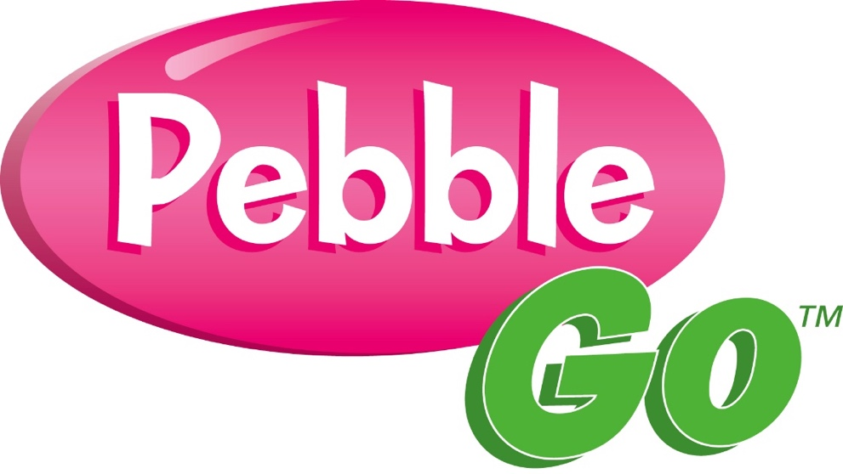

Website: http://www.pebblego.com/login/index.html?sqs=b95c570a2a95e8aa4601b8b41d72db67ae827228d1cbeff38a37611cbc6a2756

School Access: from the School Library Website

Home Access from the School Library Website

Username & Password required
- Username: livingsky
- Password: library

What is It:
Each database features expertly-leveled text and navigation specifically designed for your beginning researchers. Enriched with spoken-word audio, text highlighting and audio/video media, PebbleGo builds a foundation of research skills for every learner.

Grades: K-3

Curriculum Connections:
- Animals
- Science
- Social Studies

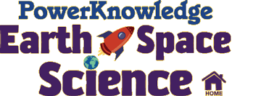

Website: http://www.pkearthandspace.com/login?username=livingsky&password=livingsky

School Access: from the School Library Website

Home Access from the School Library website:

Username & Password required
- Username: livingsky
- Password: livingsky

What is It:
PowerKnowledge Earth & Space Science is an online resource specifically designed for learners in grades 3 to 6. Comprised of curriculum correlated content, PowerKnowledge Earth & Space Science promotes digital literacy and 21st century learning skills, while offering research, report, and homework help. Instant Article Translation into over 100 languages supports English Language Learners and family literacy programs.

Grades: 3-6

Curriculum Connections:
-Earth Cycles - Ecosystems & Biomes - Energy & Matter
-Landforms - Maps - Natural Disasters
-Rocks & Minerals - Save Our Earth - Scientific Method
- Space - Weather & Climate - Water

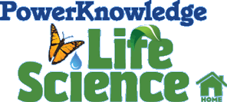

Website: http://www.pklifescience.com/login?username=livingsky&password=livingsky

School Access: from the School Library Website

Home Access from the School Library website:

Username & Password required
- Username: livingsky
- Password: livingsky

What is It:
PowerKnowledge Life Science is an online resource specifically designed for learners in grades 3 to 6. Comprised of curriculum correlated content, PK Life Science promotes digital literacy and 21st century learning skills, while offering research, report, and homework help. Instant Article Translation into over 100 languages supports English Language Learners and family literacy programs.

Grades: 3-6

Curriculum Connections:
- Animals - Classification - Endangered & Extinct Species
- Green Living - Habitats & Ecosystems - Food Chains & Food Webs
- Human Body - Life Cycles - Plants
- Scientific Method - Survival & Adaptation

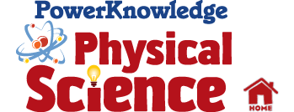

Website: http://www.pkearthandspace.com/login?username=livingsky&password=livingsky

School Access: from the School Library Website

Home Access from the School Library website:

Username & Password required
- Username: livingsky
- Password: livingsky

What is It:
PowerKnowledge Physical Science is an online resource specifically designed for learners in grades 3 to 6. Comprised of curriculum correlated content, PK Physical Science promotes digital literacy and 21st century learning skills, while offering research, report, and homework help. Instant Article Translation into over 100 languages supports English Language Learners and family literacy programs.

Grades: 3-6

Curriculum Connections:
- Atoms & Molecules - Elements & Periodic Table
- Energy & Matter - Force & Motion
- Physical Science & Our Planet - Scientific Method
- Temperature & Measurement



Website:

http://auth.grolier.com/cgi-bin/go_up_login?formu=203935&formp=ex&link=expertspaceca.grolier.com

School Access: from the School Library Website

Home Access from the School Library Website

Username & Password required
Create your own profile (with your own username and password). This also allows access to tools such as saving links, highlighting and making and saving notes.

What is It:
Expert space is a powerful digital science and social studies curriculum, which transforms the way all students access and deepen content-area knowledge and develop 21st century skills.

Grades: 5-12

Curriculum Connections:
- Great place to start your own learning on curricular topics.
-**great for Canadian Social Studies topics in Grade 5, Grade 8 and Grade 10 including Indigenous peoples.



Elementary Website: http://www.worldbookonline.com/kids/home
Middle Years Website: http://www.worldbookonline.com/student/home
All World Book Products: http://www.worldbookonline.com/?subacct=CD11146

School Access: from the School Library Website

Home Access from the School Library Website

Username & Password required
- Username: lskysd
- Password: wbhome

What is It:
World Book Kids
Based on World Book’s Discovery Encyclopedia, World Book Kids is a children’s learning website that includes thousands of easy-to-read articles, images and illustrations, interactive games and activities, and teacher resources for children.
Grades: 3-6

World Book Students
This online learning website includes articles from The World Book Encyclopedia, a Biography Center, dictionary, atlas, an extensive multimedia collection, thousands of editor-selected websites, and much more. The articles, interactive features, and quality graphic and audio components are precisely what Elementary and Middle School students need to help them focus their research and find engaging, relevant information.
Grades 5-8

Curriculum Connections:
Starting place for research/Inquiry for any unit

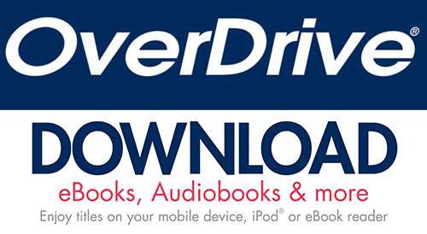

Website: https://livingskyca.libraryreserve.com
Or…download the OverDrive app (iOS and Android) to read on your mobile devices

School and Home Access from the School Library Website:
- Username: Living Sky Username
- Password: Living Sky Password

What is It:
Borrow eBooks, audiobooks, streaming video and periodicals. OverDrive is a free service offered by your library or school that lets you borrow eBooks, audiobooks, and more from their digital collections. Every OverDrive collection is slightly different because each library or school staff picks the digital content they want for their collection. All you need to get started with free digital titles from OverDrive is an internet connection and your Living Sky School Division username and password. student ID.

Grades: K-12 and professional

Curriculum Connections:
- Reading titles for a variety of levels.

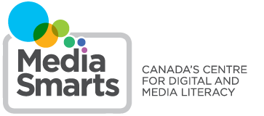

Website: http://mnet.hypernet.ca/e/

Username: Teacher: lssdt10 Student: lssds10
Password: Teacher: ntv79i Student: zizbbs

What is It:
MyWorld (5-7) This tutorial aims to teach students essential digital literacy skills through simulating their favourite online experiences. The tutorial is divided into four chapters, each of which focuses on a particular aspect of digital literacy: researching and authenticating online information, managing privacy and reputation, dealing with online relationships and using digital media in an ethical manner.

Passport to the Internet (3-5) This interactive tutorial teaches students the critical thinking skills they need to apply to their online experiences, including online safety, authenticating online information, recognizing online marketing ploys, protecting their privacy, managing online relationships and dealing with cyberbullying.

Web Awareness Workshop Series: Includes Cyberbullying: Encouraging ethical online behavior, Safe Passage: Teaching kids to be safe and responsible online, Kids for Sale: Online privacy and marketing, Fact or Folly: Authenticating online information, **Growing with the Net: The early years (Ages 4-12), **Growing with the Net: The teen years (Ages 13-17). Each workshop includes a flash tutorial version with audio (for self-directed learning), PowerPoint presentation with speaking notes, workshop guide with background information.

**Recommended for use with teachers and with parents.

Curriculum Connections:- Wide range of digital media resources.


Elementary Website: http://school.eb.com/levels/elementary
Grades: 3-6

Middle Years Website: http://school.eb.com/levels/middle
Grades 5-8

School Access through the School Library Website

Home Access: via the SK Curriculum Site, https://curriculum.gov.sk.ca. Scroll to the bottom right hand menu and select Online Magazines, Journals and Newspapers. From the left-hand menu in the new window select All Licensed K-12 Student Resources. Scroll through the listed resources to find the resource you want. Select home access and sign in using your Blackboard username (first.last) and password, month and day of birth. (mmdd).

What is it:
Britannica School's extensive catalog of differentiated articles, multimedia features, translation and audio options, vocabulary support, and adaptive reading levels make the research experience manageable and accessible to students of all different learning levels and abilities.

Curriculum Connections:
Starting place for research/Inquiry for any unit

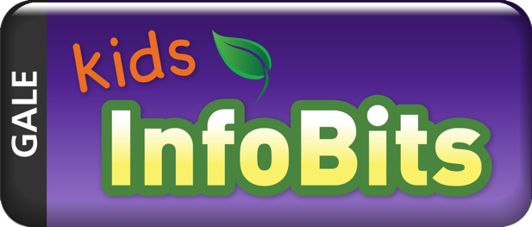

Website: Available from the Saskatchewan Curriculum Website. http://external.edonline.sk.ca/public/school_access.html?url=http://infotrac.galegroup.com/itweb/saskplschools?db=ITKE

School Access through the School Library Website

Home Access: via the SK Curriculum Site, https://curriculum.gov.sk.ca. Scroll to the bottom right hand menu and select Online Magazines, Journals and Newspapers. From the left-hand menu in the new window select All Licensed K-12 Student Resources. Scroll through the listed resources to find the resource you want. Select home access and sign in using your Blackboard username (first.last) and password, month and day of birth. (mmdd).

What is It:
A content-rich, authoritative, easy-to-use resource featuring age-appropriate content covering a broad range of educational topics. It features a modern, graphical interface, great new content from trusted sources, more intuitive navigation, improved resources, and much more.

Grades: 4-6

Curriculum Connections:
Non-fiction reading and inquiry based projects/exploration



Website: http://search.proquest.com/canadiannewsmajor/news/fromDatabasesLayer?accountid=44331

School Access through the School Library Website

Home Access: via the SK Curriculum Site, https://curriculum.gov.sk.ca. Scroll to the bottom right hand menu and select Online Magazines, Journals and Newspapers. From the left-hand menu in the new window select All Licensed K-12 Student Resources. Scroll through the listed resources to find the resource you want. Select home access and sign in using your Blackboard username (first.last) and password, month and day of birth. (mmdd).

What is It:

Canadian Major Newspapers. Included are national and leading regional papers such as National Post, Calgary Herald, Edmonton Journal, Montreal Gazette, Ottawa Citizen, Regina Leader Post, Vancouver Sun and the Victoria Times-Colonist.

Coverage: 1985 - current

Subject coverage
- Canadian news
- Canadian general reference
- Canadian business
- Canadian finance

Grade Level: 8 - 12

Curriculum Connections:
Current Events, research and inquiry

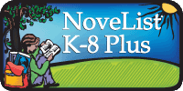

Website: Available from the Saskatchewan Curriculum Website. http://search.ebscohost.com/login.aspx?authtype=ip,cpid&profile=novpk8

School Access through the Library Website

Home Access: via the SK Curriculum Site, https://curriculum.gov.sk.ca. Scroll to the bottom right hand menu and select Online Magazines, Journals and Newspapers. From the left-hand menu in the new window select All Licensed K-12 Student Resources. Scroll through the listed resources to find the resource you want. Select home access and sign in using your Blackboard username (first.last) and password, month and day of birth. (mmdd).

What is It:
NoveList K-8 Plus is a trusted source of read-alike recommendations specifically for younger readers. It helps kids find books that are just right for their reading level and interests. Parents, teachers, and librarians can also find tools to teach with books and engage young readers.

Grades: K-8 Students and Teachers

Curriculum Connections:
Assistance for novel selections

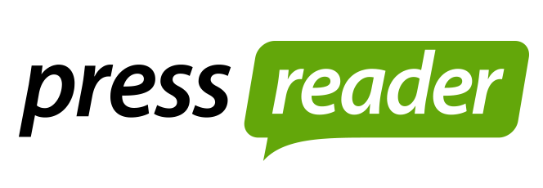

Website: Available from the Saskatchewan Curriculum Website. http://external.edonline.sk.ca/public/school_access.html?url=http://www.pressreader.com

School Access through the School Library Website

Home Access: via the SK Curriculum Site, https://curriculum.gov.sk.ca. Scroll to the bottom right hand menu and select Online Magazines, Journals and Newspapers. From the left-hand menu in the new window select All Licensed K-12 Student Resources. Scroll through the listed resources to find the resource you want. Select home access and sign in using your Blackboard username (first.last) and password, month and day of birth. (mmdd). Note Press Reader replaced Library PressDisplay.

What is It:
Library.PressDisplay.com is the most convenient and complete way to read all your favorite newspapers and magazines on one site. With Library PressDisplay users gain access to publications from within the library, from home and around the world on the day they are published. Library.PressDisplay.com enhances your reading experience with a simple user interface and easy-to-use navigation tools.

Grades: 5-12, teachers and all families

Curriculum Connections:
- Social Studies & Current Events
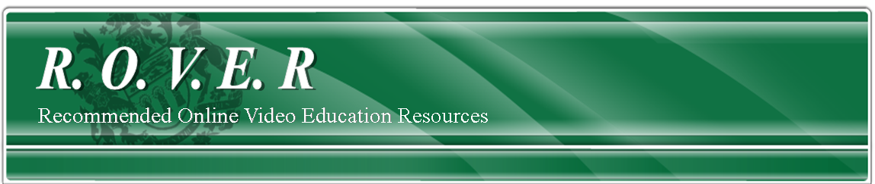

Website: https://rover.edonline.sk.ca/index.htm

School Access through the School Library Website

Home Access: via the SK Curriculum Site, https://curriculum.gov.sk.ca. Scroll to the bottom right hand menu and select Online Magazines, Journals and Newspapers. From the left-hand menu in the new window select ROVER. Sign in using your Blackboard username (first.last) and password, month and day of birth. (mmdd).

What is It:
ROVER (Recommended Online Video Education Resources) is a video streaming service for Saskatchewan teachers and students in the PreK-12 education system. It is managed and maintained by the Saskatchewan Ministry of Education. ROVER is a video-on-demand service that provides teachers and students with the convenience of immediate access to streamed, educational videos that support curricula. ROVER videos are housed on a server located in a school or school division network so there are no bandwidth issues, resulting in better picture quality and continuous play of videos without pauses. The videos are intended for viewing on the streaming site and not for copying or downloading.

Grades: K-12

Curriculum Connections:
- Video’s for each Grade’s Curricular Subject



Website: http://www.criterionondemand.com/

Log In: Access through School Library website

What is It:
Criterion Pictures has developed an on-line digital delivery feature film platform called Criterion-on-Demand. The goal is to provide easy access to educationally relevant feature films.

Note that Criterion On-Demand focuses on a post-secondary audience. That being said, films such as The Giver and The Hunger Games are available as well as some children’s films.

Criterion-on-Demand is s streaming only services. The films cannot be downloaded.

Grades: K-12

Curriculum Connections:
- Wide range of feature films

STEAM Kits

http://www.lskysd.ca/ProgramsLearning/CurriculumAndInstruction/Resources/Pages/STEAM-Kits.aspx
- Camera Kits
- ​MakerSpace Tools
- ​Probes and Sensors
Download listSTEAM Kitsv2.docx
Contact Donna DesRoches donna.desroches@lskysd to request items

